**GSS**

**UD Physical server Deployment**

|  |  |  |  |
| --- | --- | --- | --- |
|  |  | | |
| **Document name** | UD Physical Server Deployment Ver 1.docx | | |
|  |  | | |
| **Company** |  | **Information class** | Internal, HCLClassification=Confidential |
| **Version** | 1 | **Document status** | Draft |
| **Author** |  | **Approved by** |  |
| **Date** | 2022-08-09 | **Approved date** |  |
|  |  |  |  |
|  |  | | |

History

|  |  |  |  |
| --- | --- | --- | --- |
| **Version** | **Date** | **Author** | **Description** |
| 1.0 | 2022-10-14 | GSS OTD Team | Initial document |
|  |  |  |  |

Summary

This document describes the installation of Physical server using Service profile and Template

# Table of Contents

# Introduction

# How to Login to Dell OME appliance

# Service profile creation

# Template deployment

# Installing Operating system using SAN boot disk

# How to update Drivers and Firmware

# How to Configure NIC Teaming

# Place server in Right OU and check the Respective GPO’s

# Tools Installation and configuration

# i) Big Fix Agent installation and configuration

# ii) Nimsoft Agent installation and configuration

# iii) Qualys Agent installation

# iv) Qradar Agent installation

# v) TSM Agent installation

# Backup configuration For nodes

# Cluster Resource Backup Configuration

# Introduction

The purpose of this document is how to build a physical server Using Template and service profile

**2.** **How to Login to Dell OME Appliance**

Browse the URL 10.80.32.132 from any UD jump server and it opens the page as mentioned below. Provide the credentials to login to the OME Console.

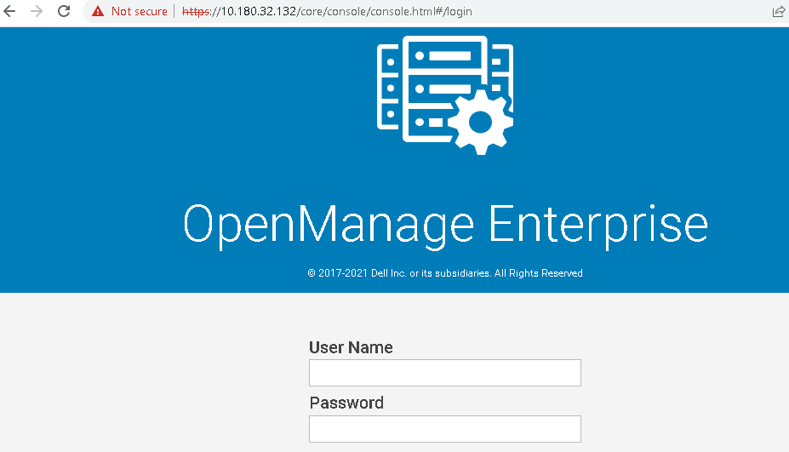

Home page of Dell OME appliance looks like below mentioned

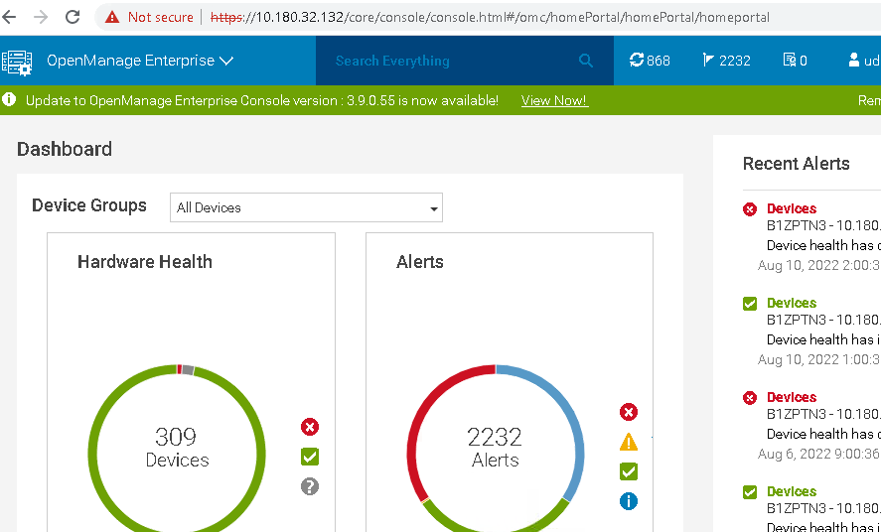

# 3. Service Profile Creation

1. Select Templates from the Configuration tab in the home page after logging in to OME appliance console

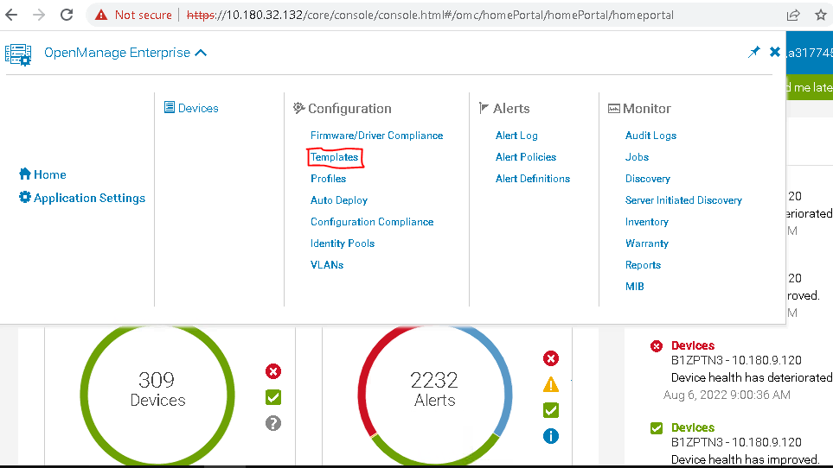

1. Select Advanced filters and search for existing template based on the requirement and it will list the available templates

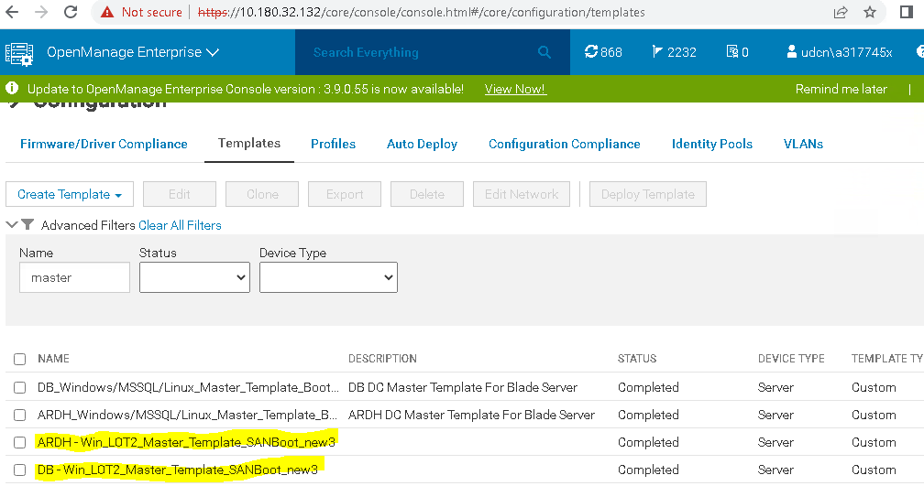

1. Select the template and select edit

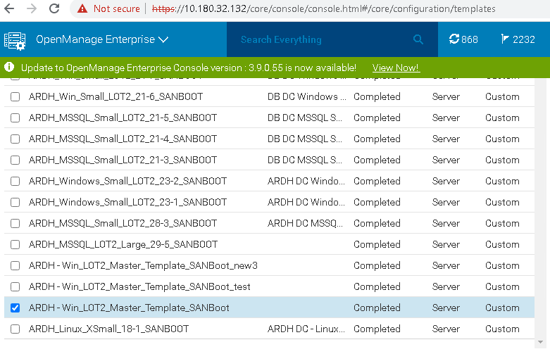

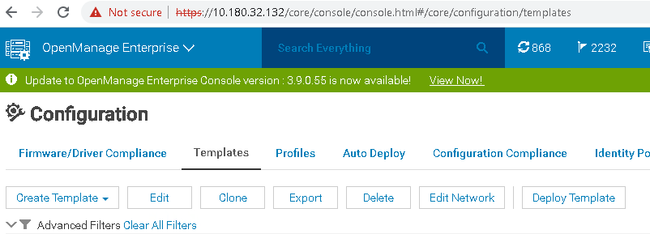

1. Rename the Template as per the requirement and click Finish. This will create the Clone template of existing template

ARDH- Represents name of the DC, xSmall represents- T shirt size 31-7 is Chasis Number and slot number of the blade

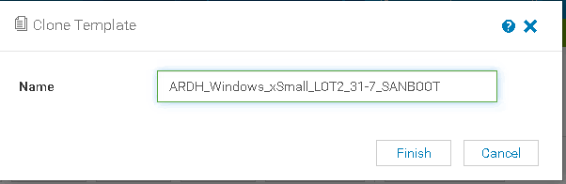

1. Search for the template using Chasis and Slot number, that will display the Cloned template using the existing template

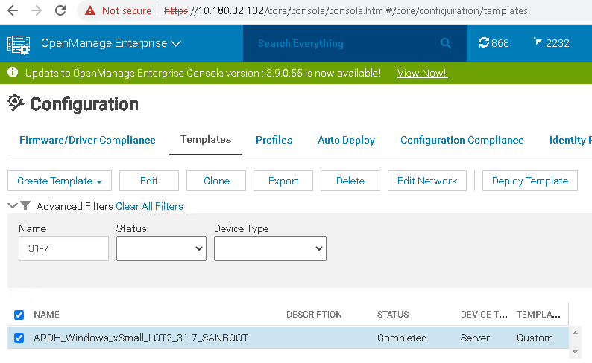

1. Select the template and click Edit to edit the settings as per the requiremnet
2. Provide the description name as the Template name for easy identification

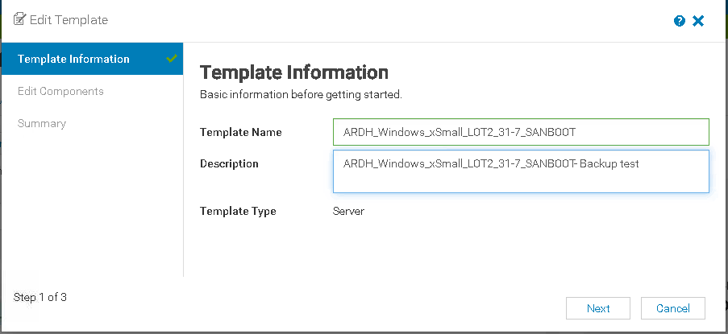

1. Don’t change any default settings for BIOS, Boot and Networking

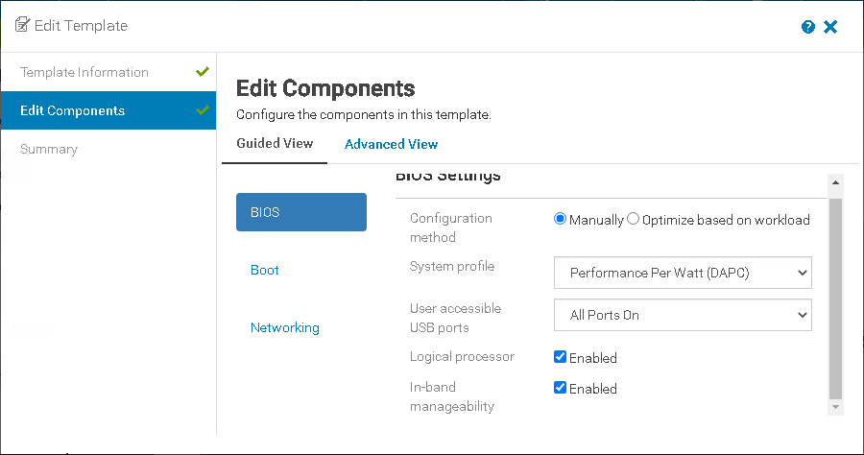

1. Keep the BIOS settings as UEFI

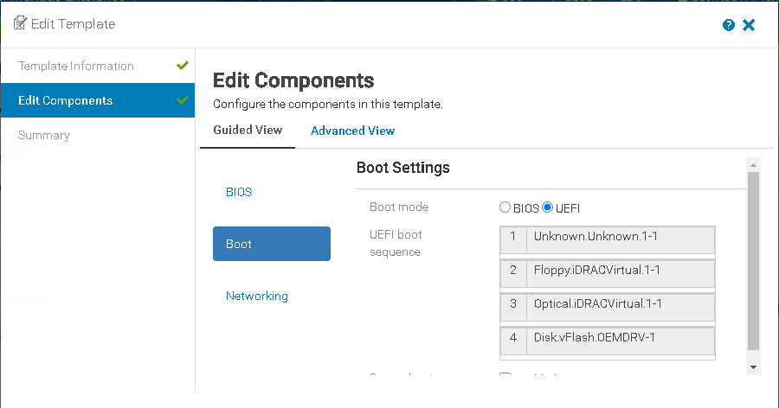

1. Select Identity pool as ARDH or DB based on the site

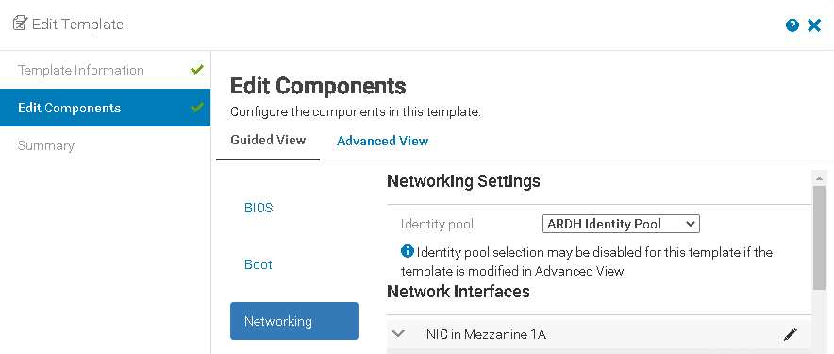

1. In the Advanced view of Edit components under NIC Mezzanine.1A-2-1 and Mezzanine. 1A-1-1 should have the below values based on the ARDH and DC

|  |  |  |
| --- | --- | --- |
| 20:01:d0:39:ea:1b:55:6f | DB Lower | 4021 |
| 20:03:d0:39:ea:1b:55:6f | DB Lower |  |
| 20:03:d0:39:ea:1b:55:97 | ARDH Lower |  |
| 20:02:d0:39:ea:1b:55:97 | ARDH Lower |  |
| 20:02:d0:39:ea:1b:55:6f | DB Upper | 4022 |
| 20:04:d0:39:ea:1b:55:6f | DB Upper |  |
| 20:04:d0:39:ea:1b:55:97 | ARDH Upper |  |
| 20:01:d0:39:ea:1b:55:97 | ARDH Upper |  |

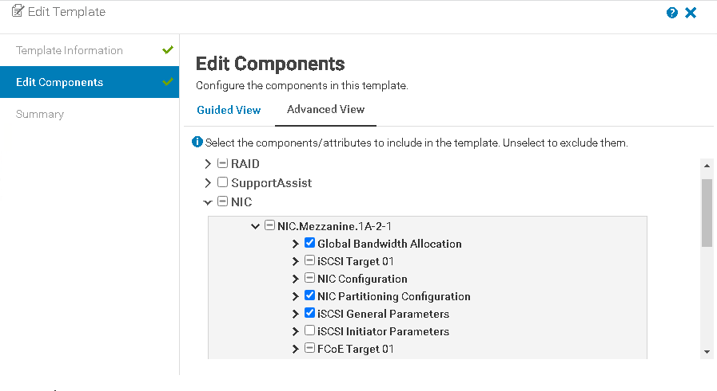

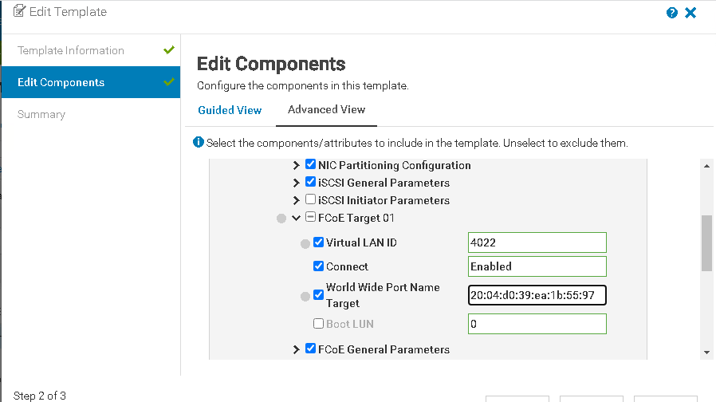

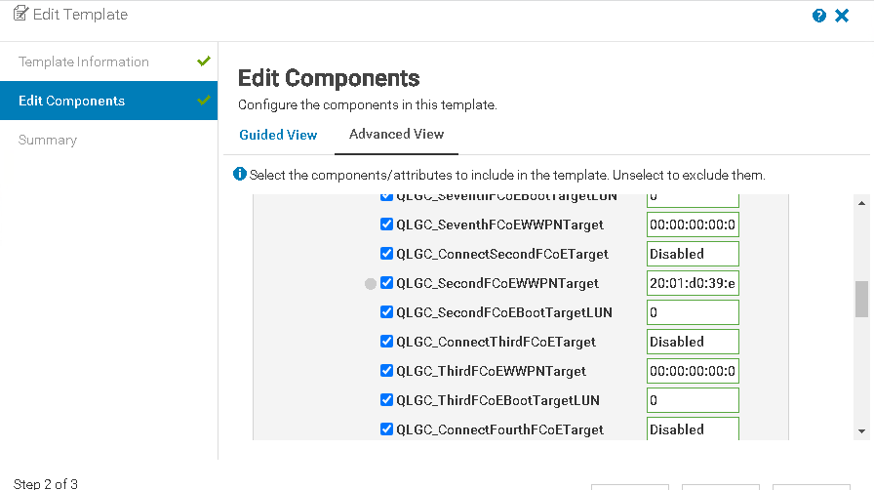

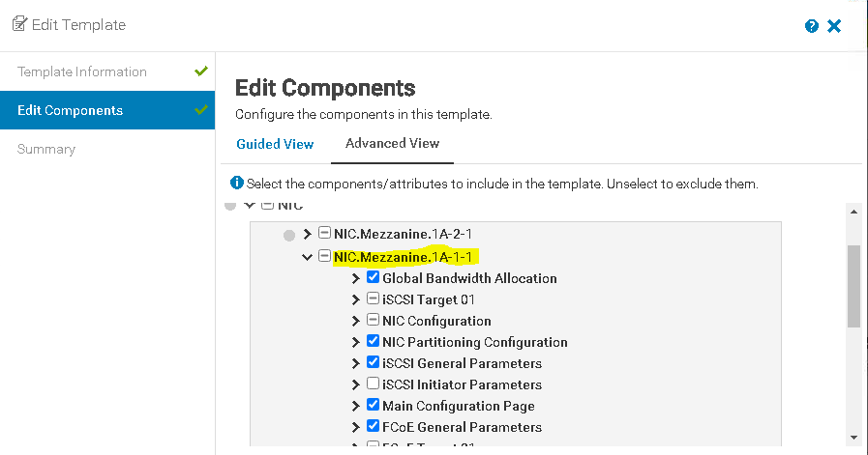

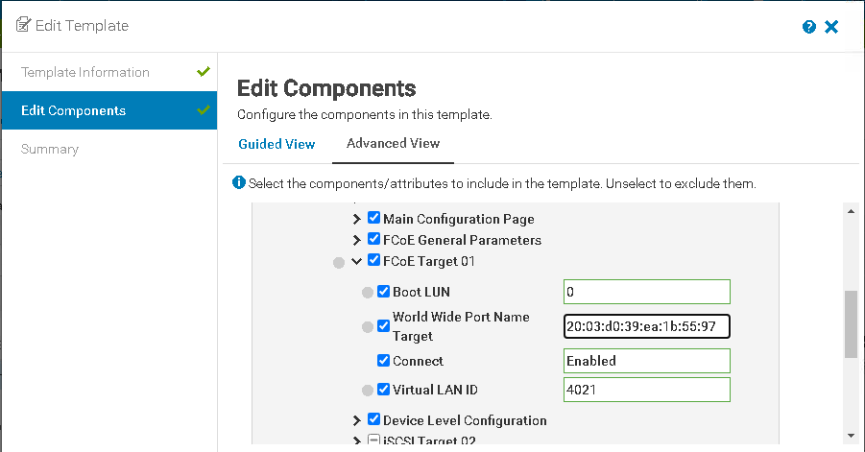

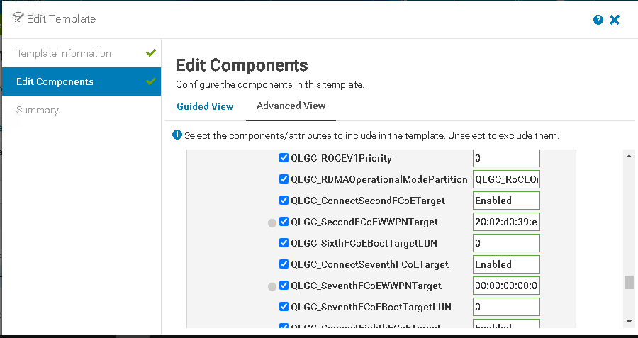

1. Once the required values are edited , click finish to close the edit template window

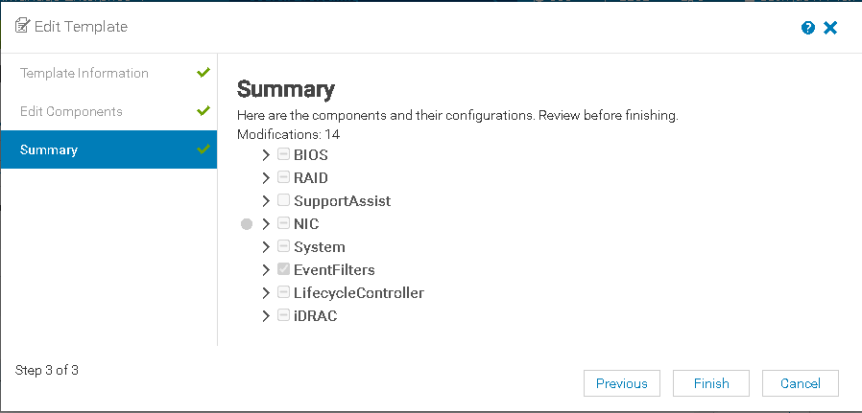

**4. Template Deployment**

1. Once the setting are edited in the template, select template and select Deploy Template

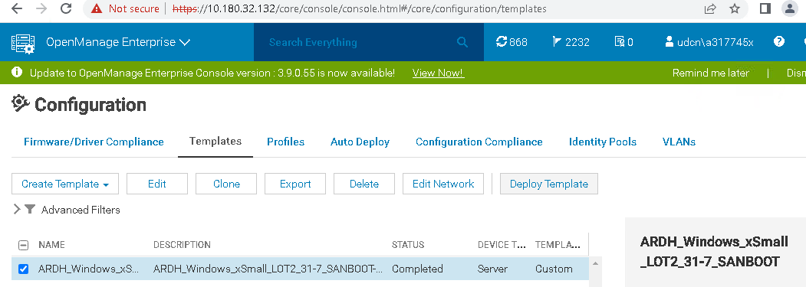

1. In the target tab under select Devices, click select

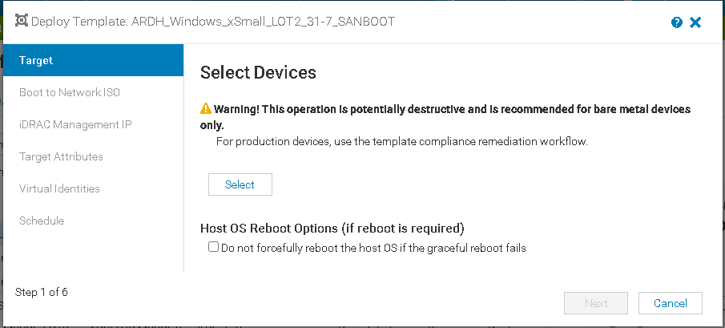

1. In all devices, select the Filter and in the IP column, select the IP of the iDRAC and select ok

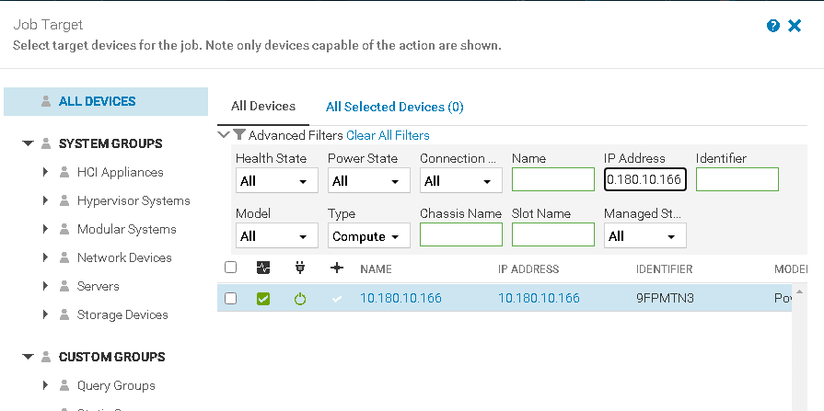

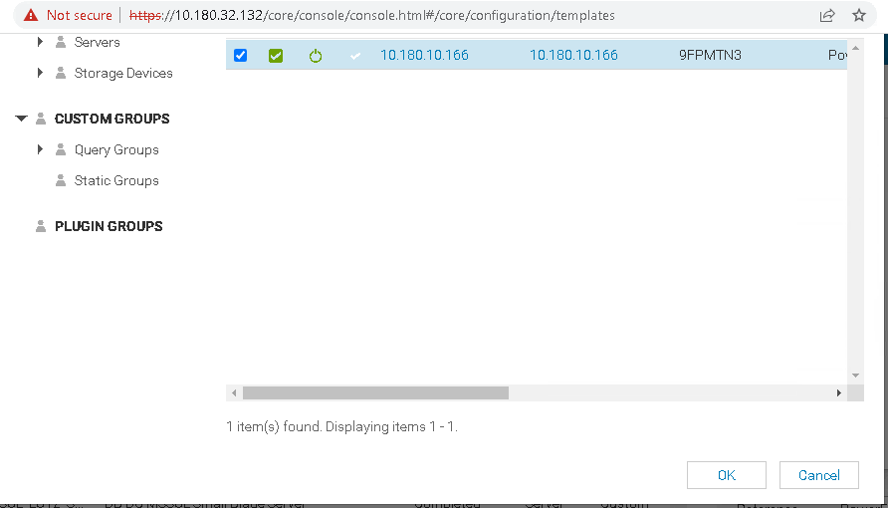

1. Once the required iDRAC IP is selected, it show as 1 devices selected

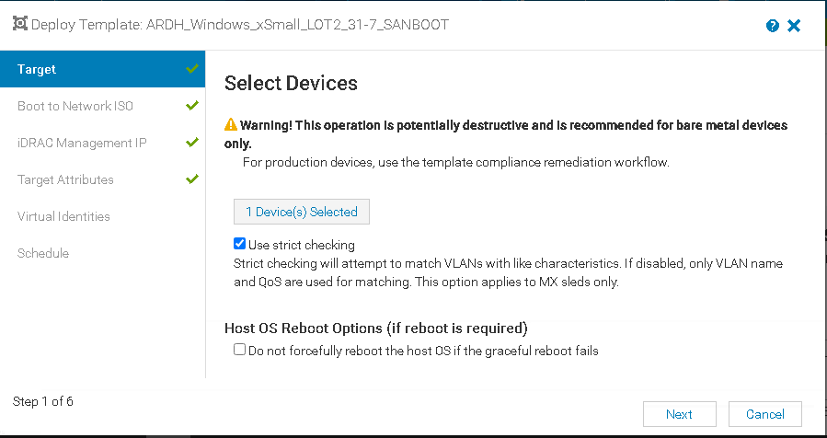

1. In the Boot to Network ISO don’t select anything

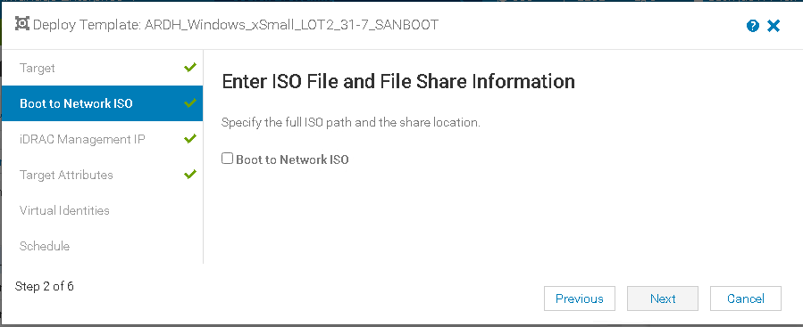

1. Keep the default settings in the iDRAC Management IP

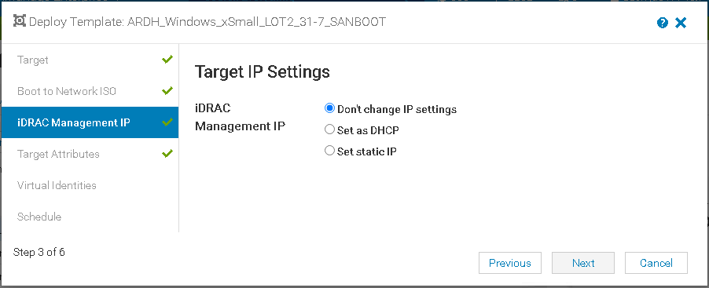

1. Keep the default values for BIOS

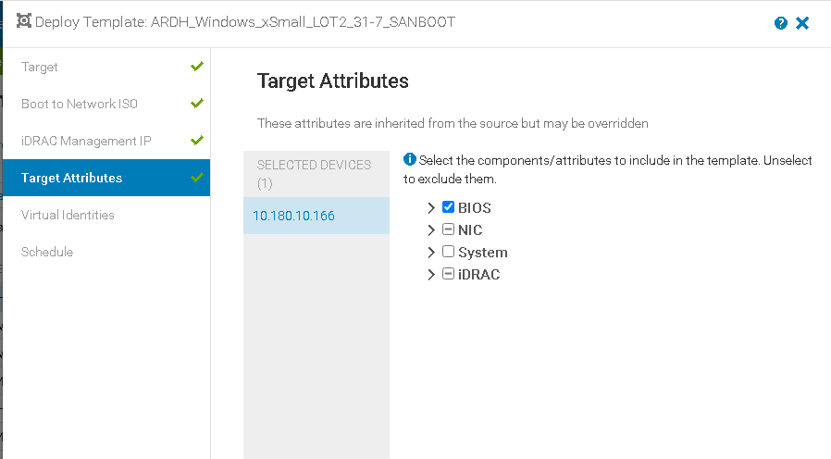

1. In the Virtual Identities, Select Reserve Identities

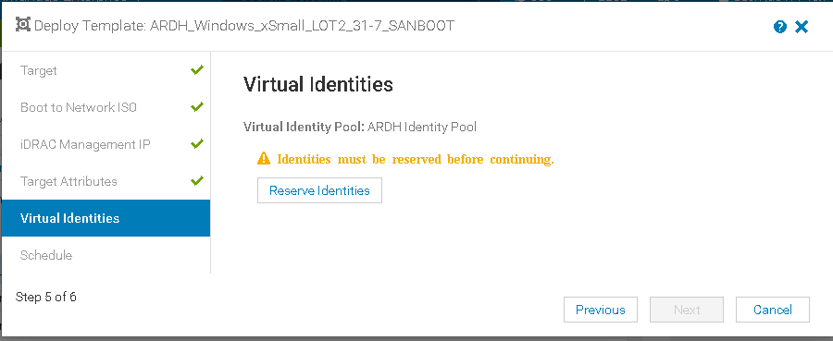

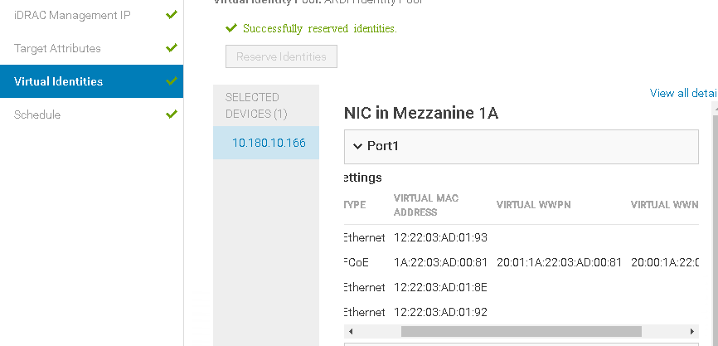

1. Once all the required settings are selected, select finish to start the Job now.

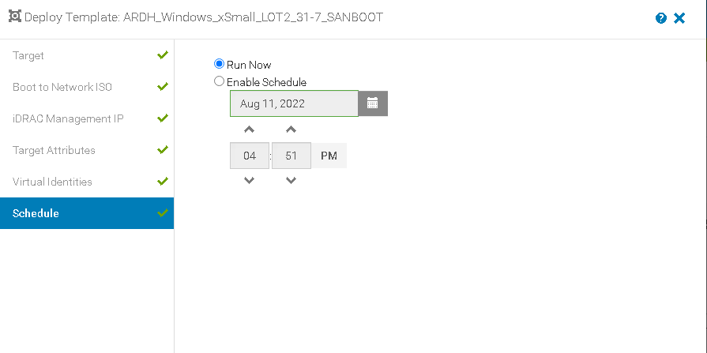

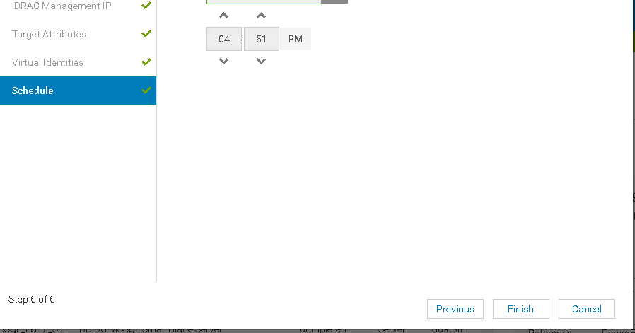

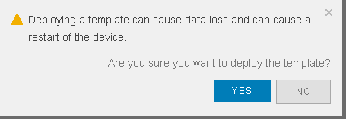

1. Once the Job is initiated, Same can be monitored under the scheduled jobs.

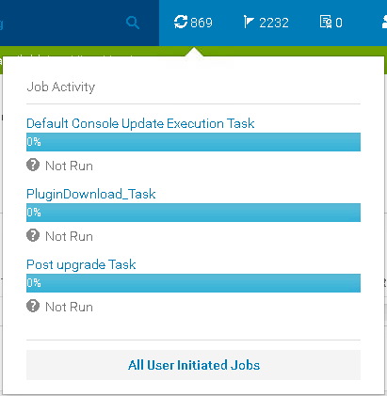

1. Using View Details, real time Template creation can be monitored

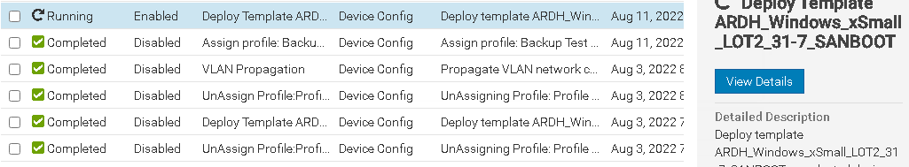

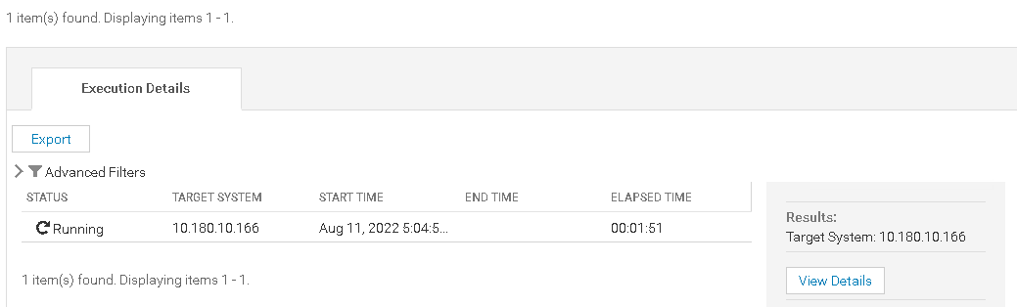

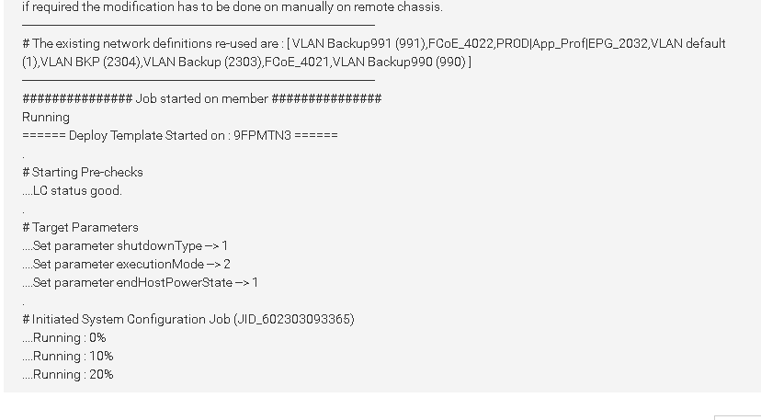

Dell Blade Groups DC

Lot 1: <https://10.180.9.201>

Lot2 (Group1) : <https://10.180.9.202>

Lot2 (Group2): <https://10.180.9.203>

ARDH Side

Lot1: <https://10.180.10.201>

Lot2 (Group1) : <https://10.180.10.202>

Lot2 (Group2) : <https://10.180.10.203>

Dell OME Appliance URI:

<https://10.180.32.132/>

# Installing Operating system using SAN boot disk

1. Login to Blade groups IP based on the Site. Once login to the Console, all the Chasis belongs to that particular group will display in the left side

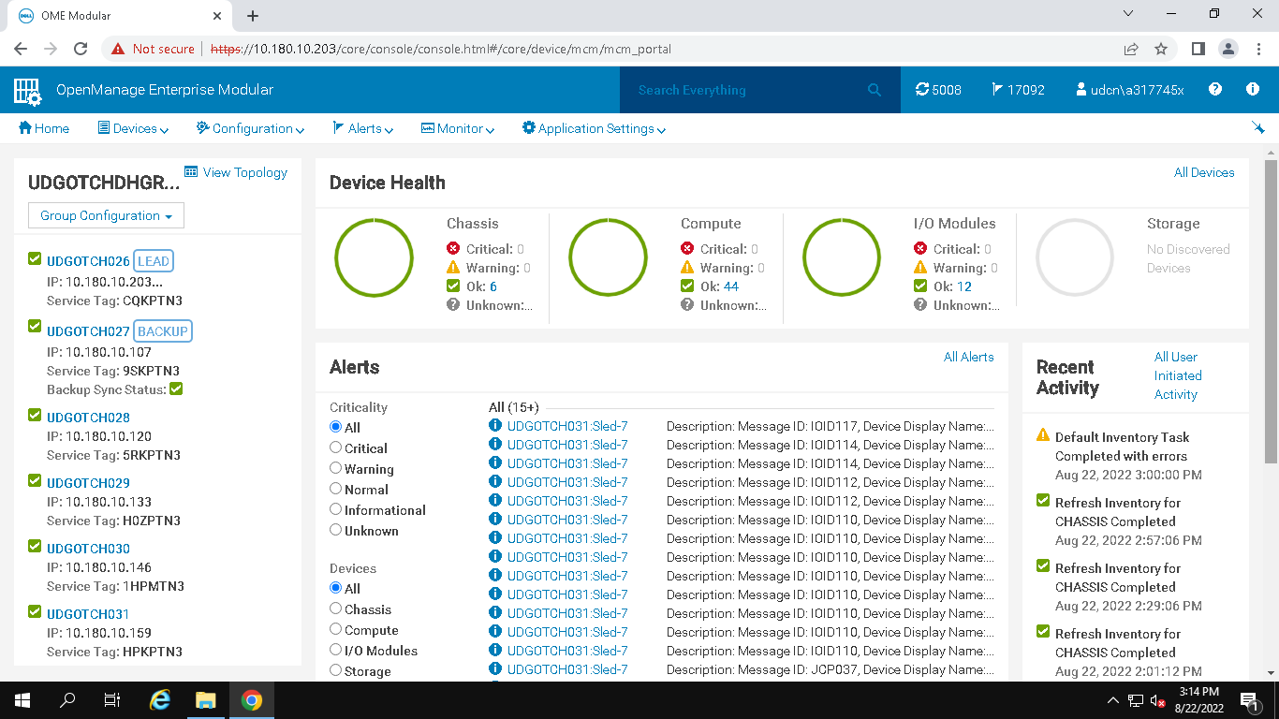

1. Select the required chasis, it will open a new page with the list of blades available.

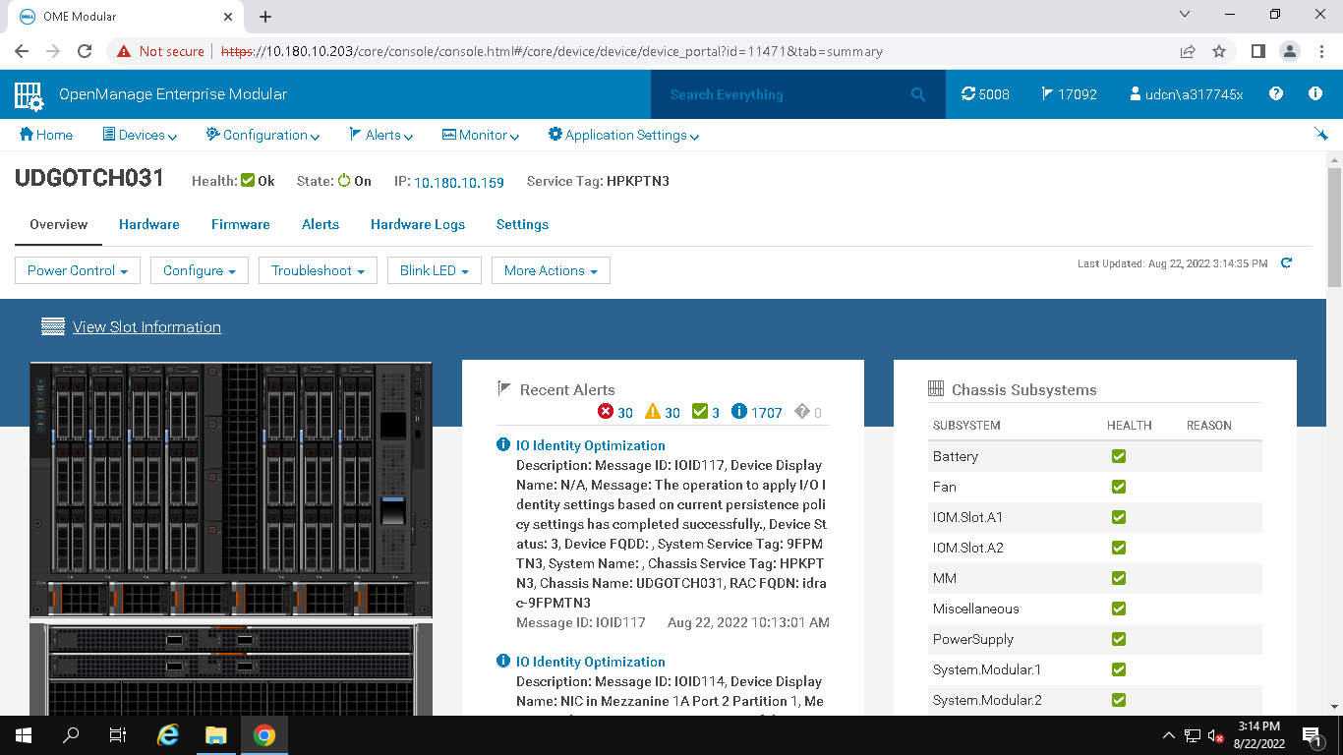

1. Select the slot from chasis, where OS needs to be installed

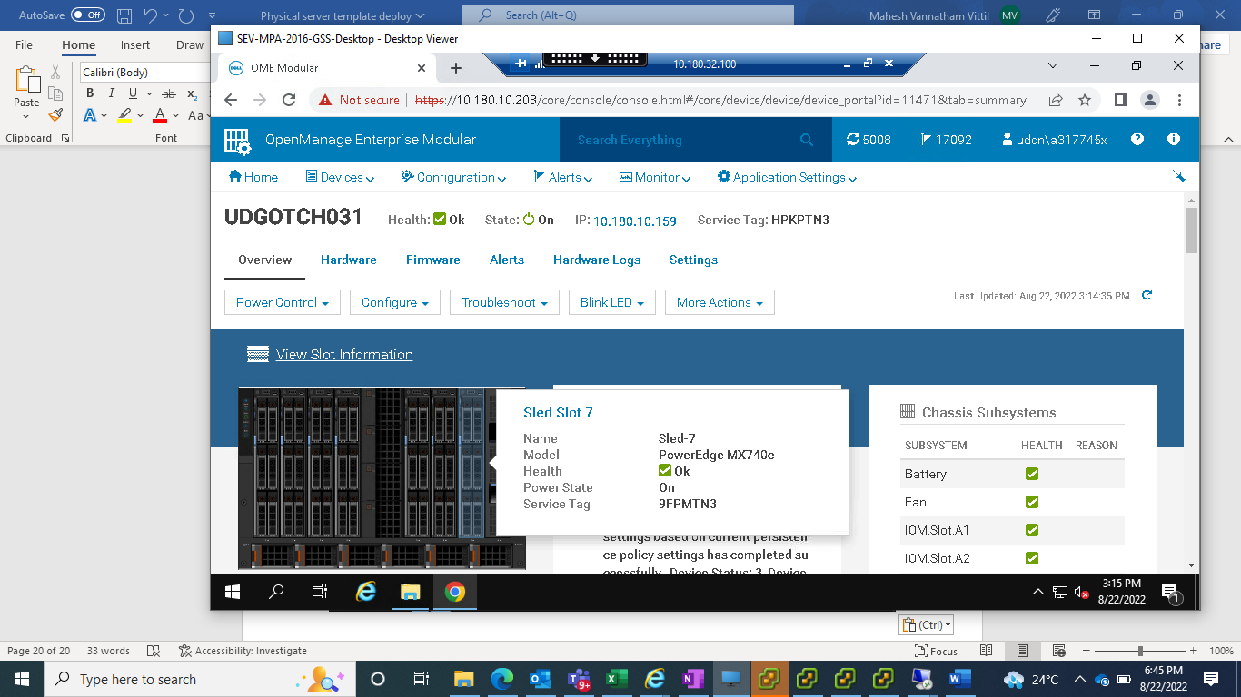

1. Launch Vitual console as shown below

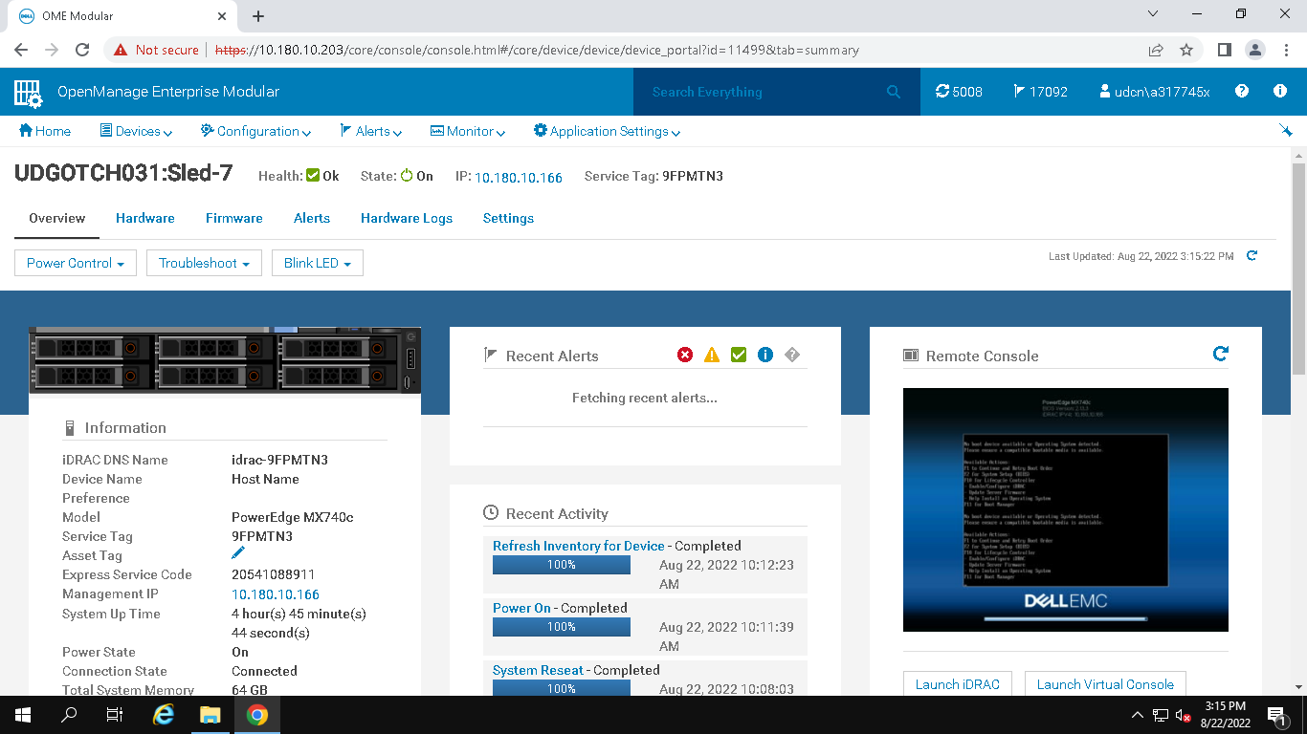

1. Select advanced to complete the login process

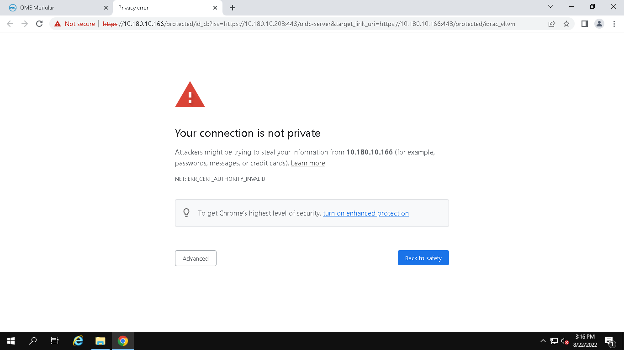

1. Once the Virtual console is loaded properly, mount the ISO as shown in below screenshots

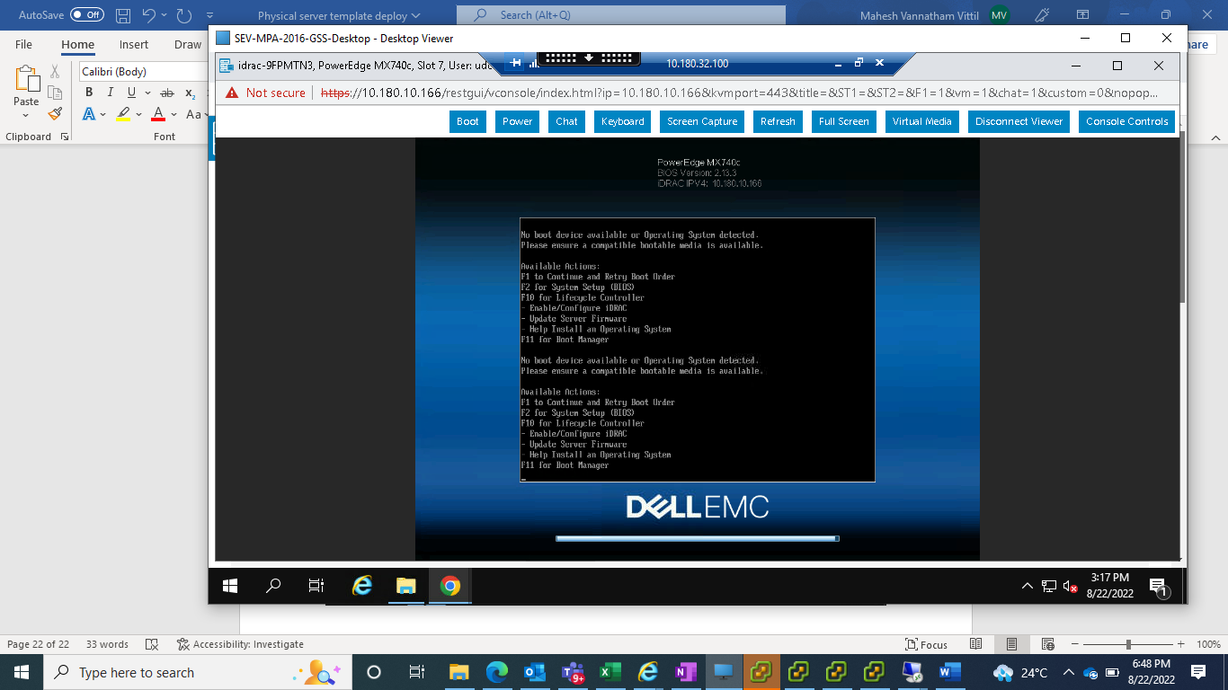

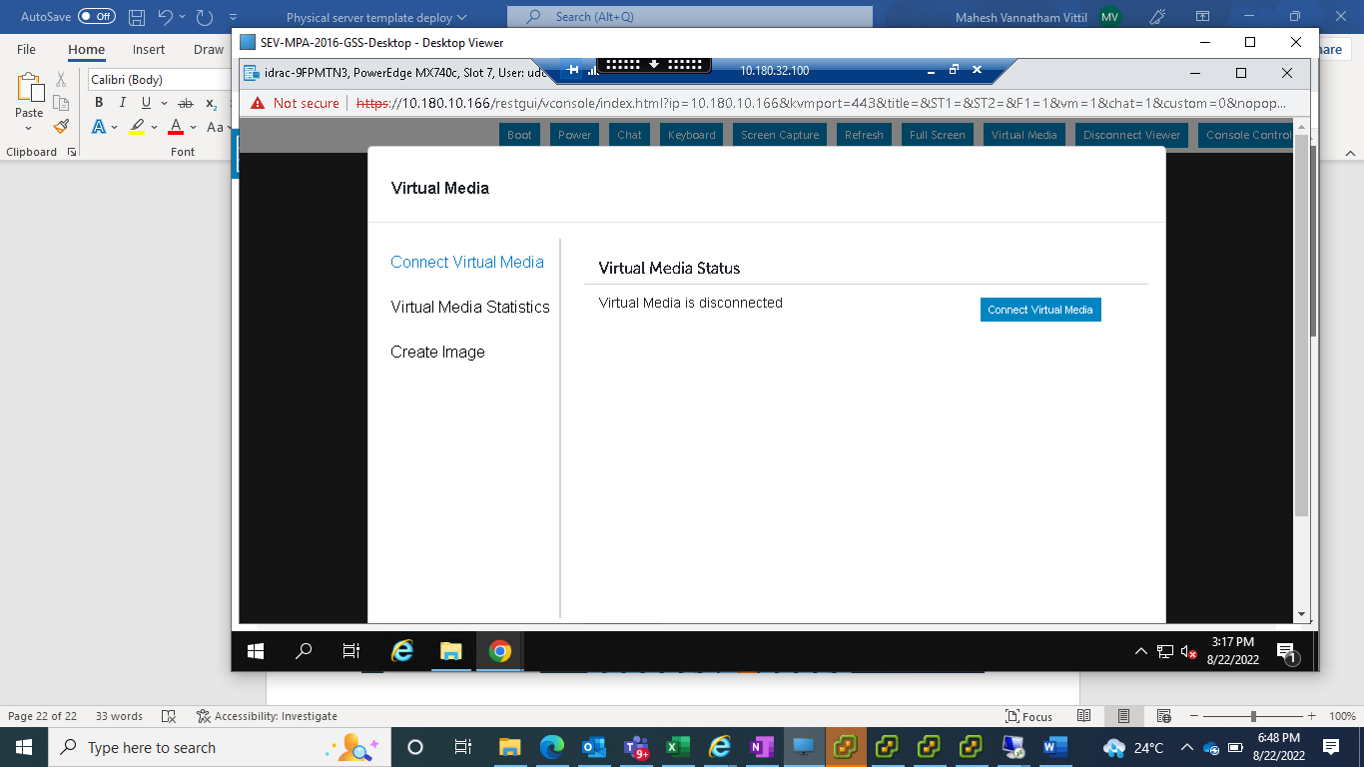

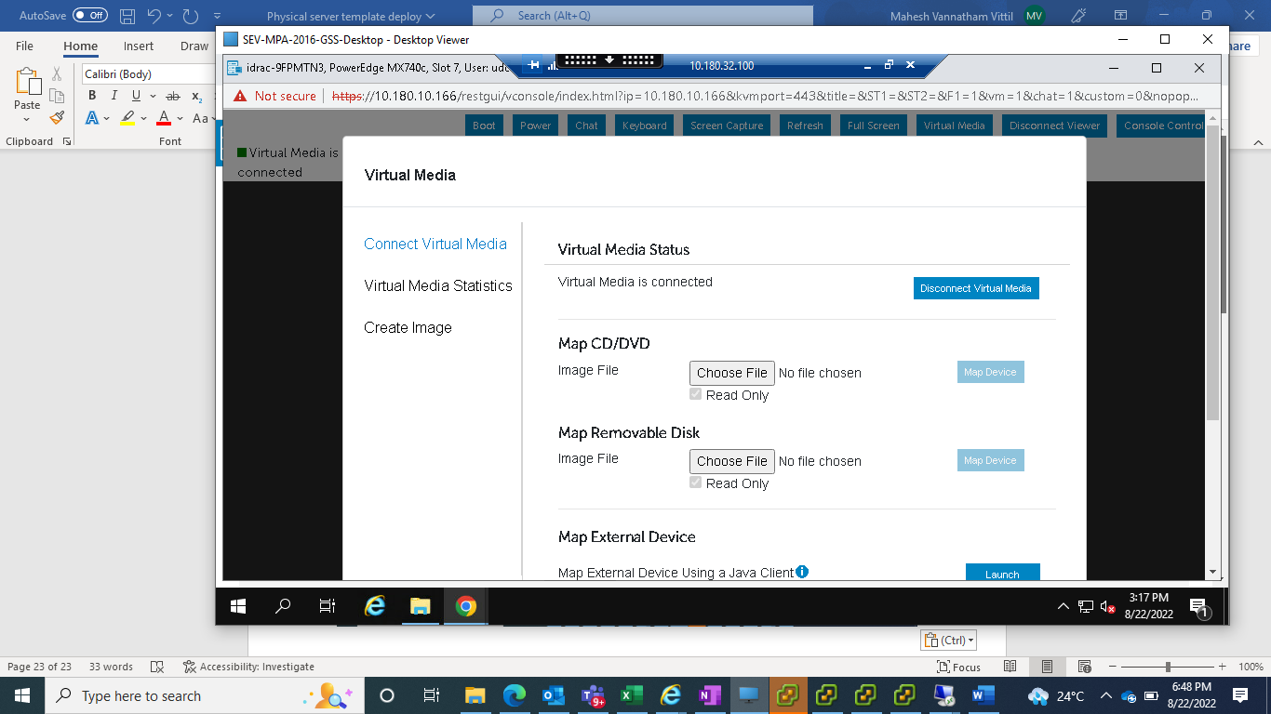

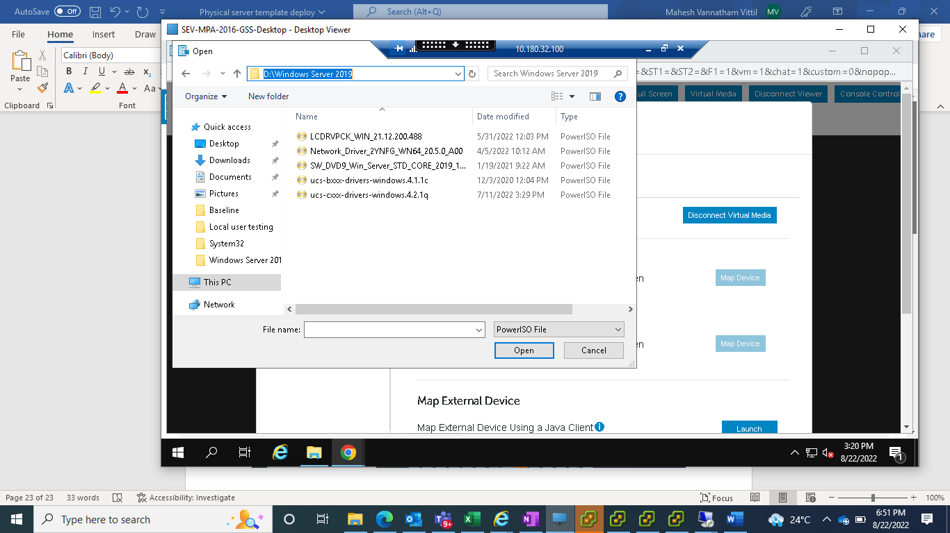

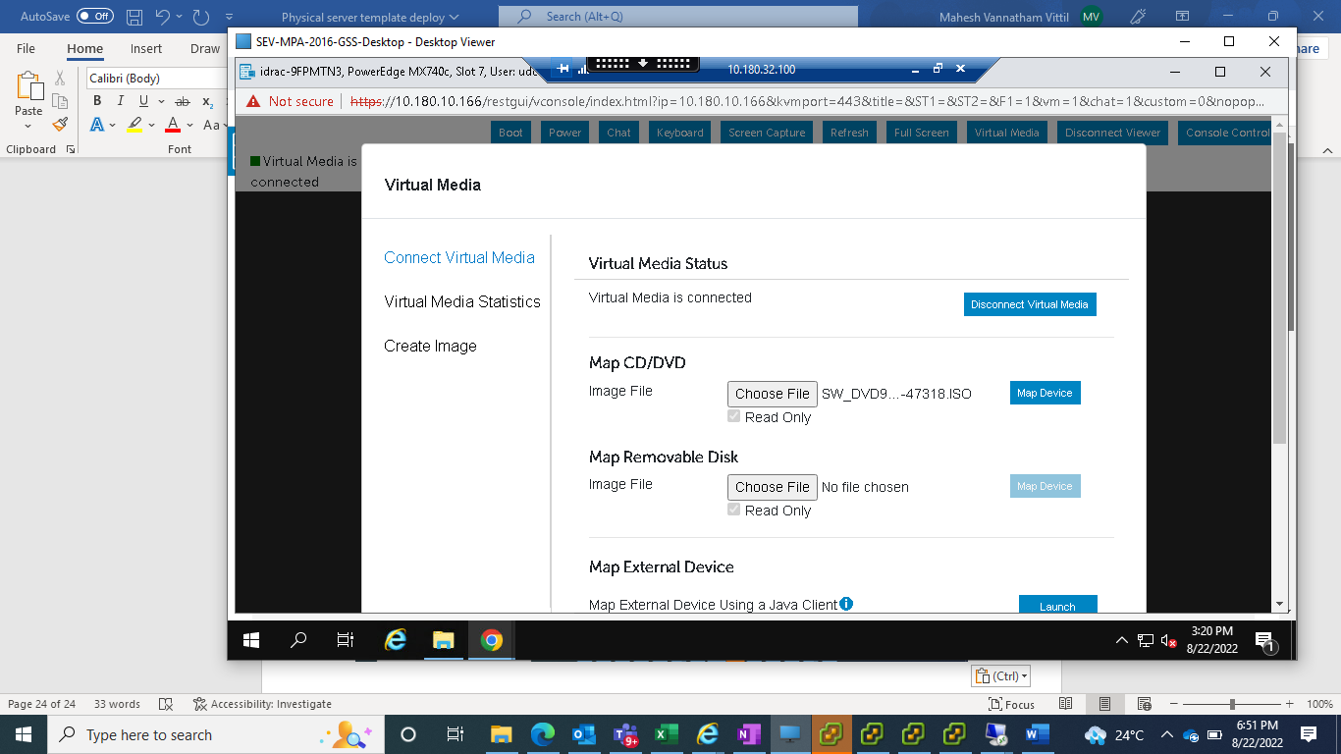

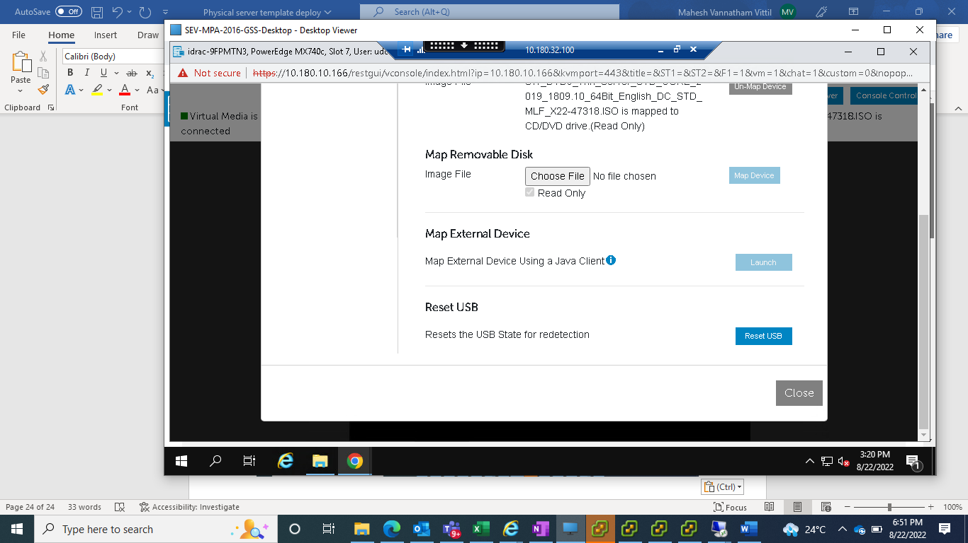

1. Once ISO is mounted, reboot the server and in Boot Options select LifeCycle Controller( for 2019). For 2016 directly boot for the virtual media

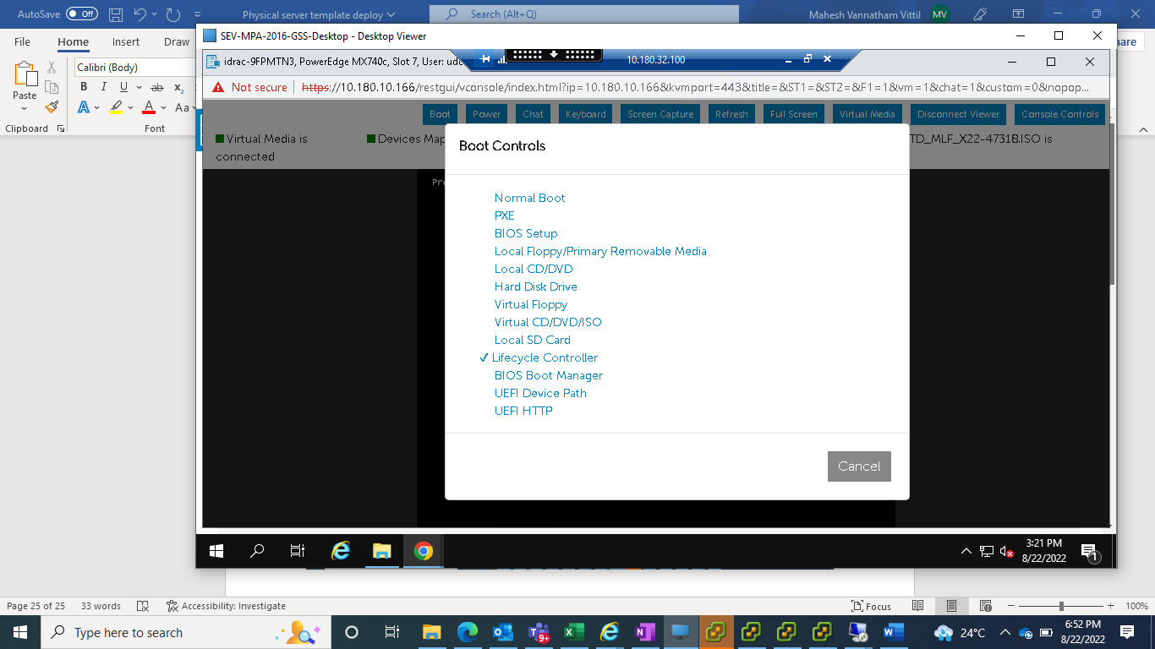

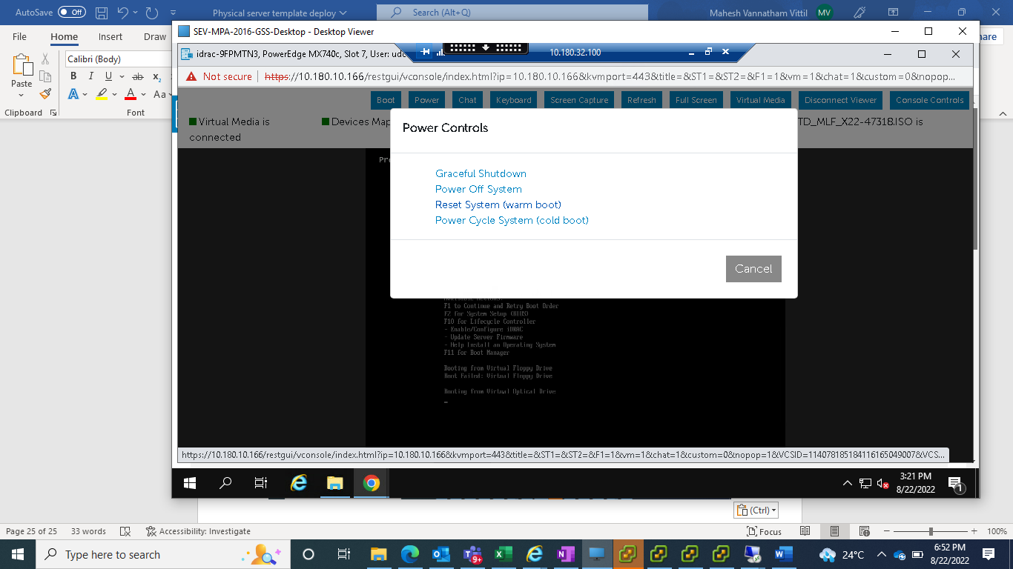

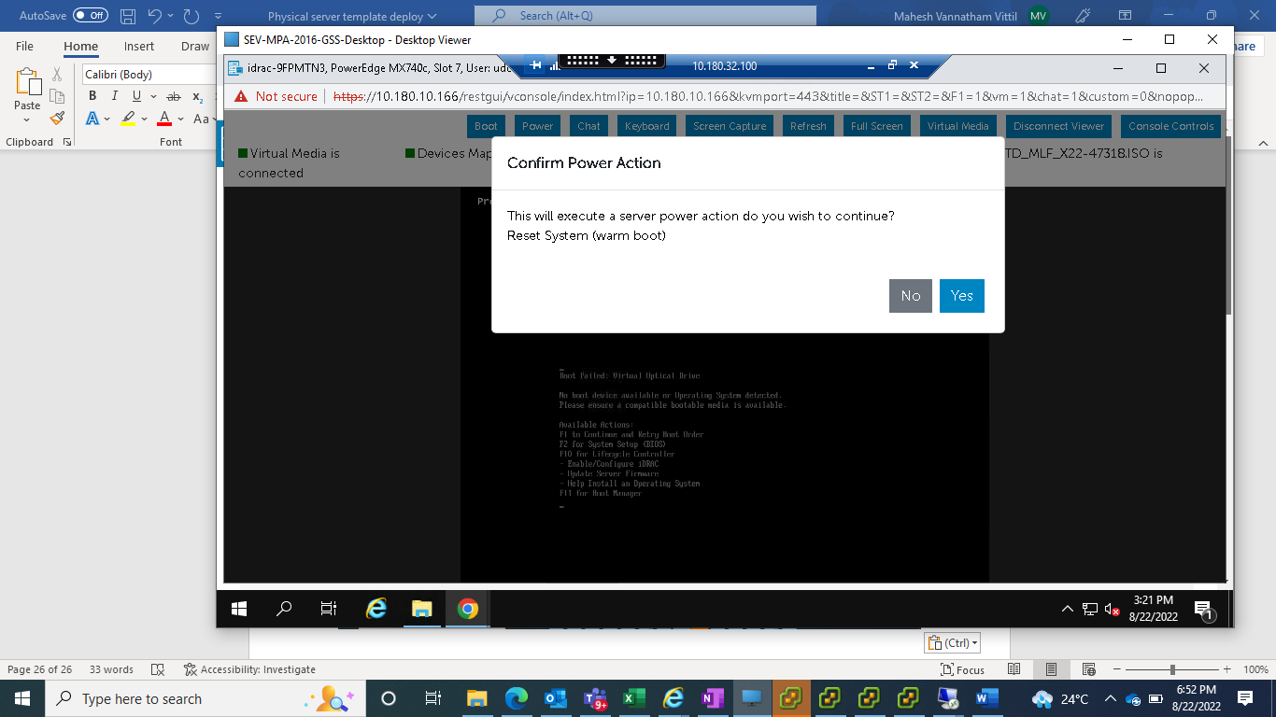

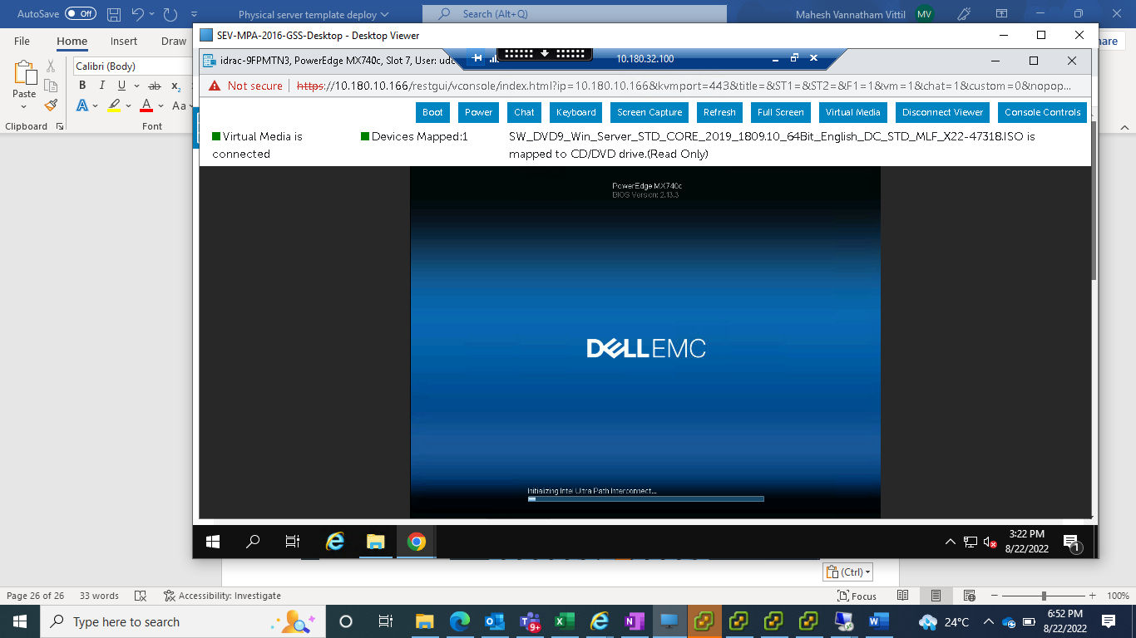

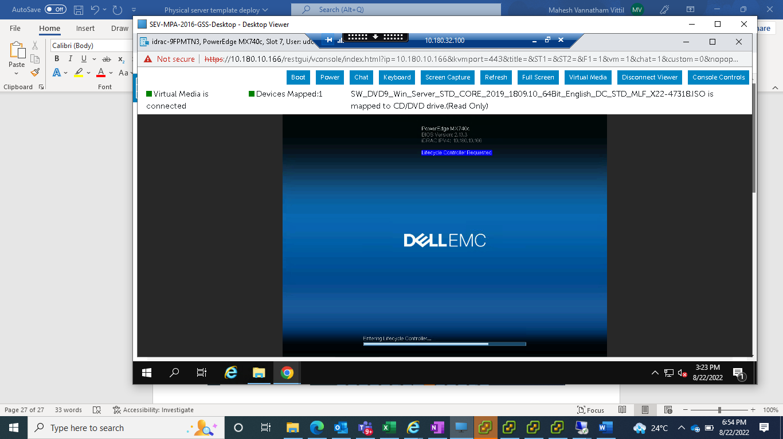

1. After successful reboot ,Lifecycle Controller will be launched.Click cancel to proceed further

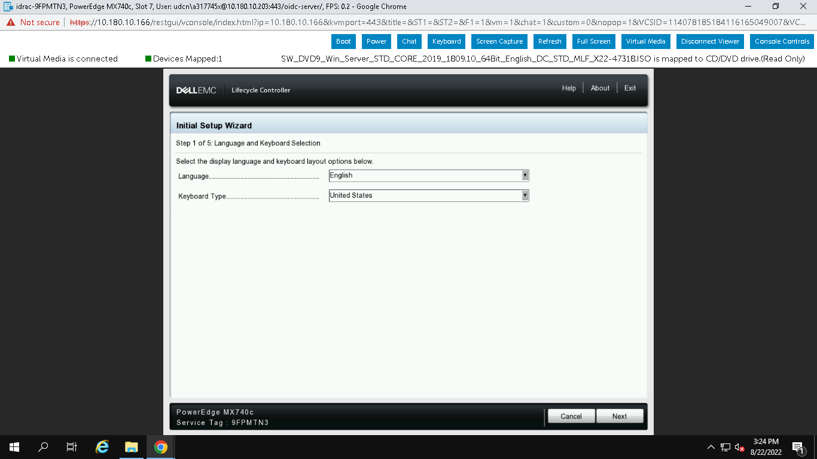

1. Click yes to proceed further

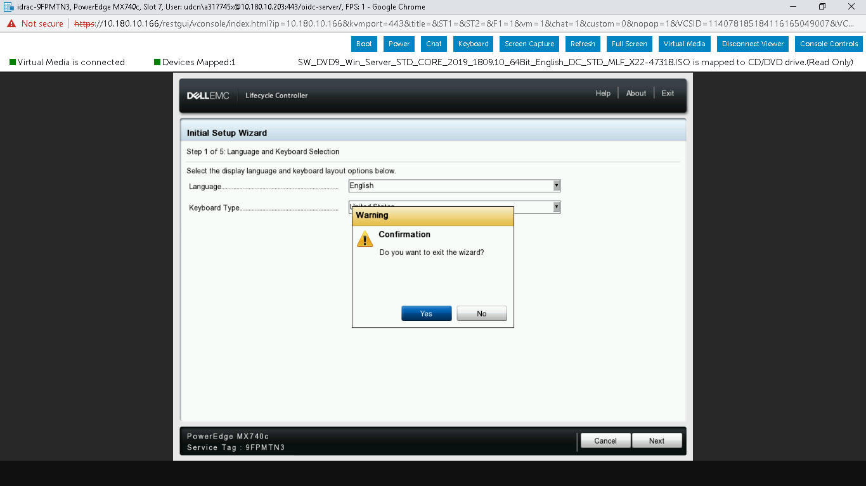

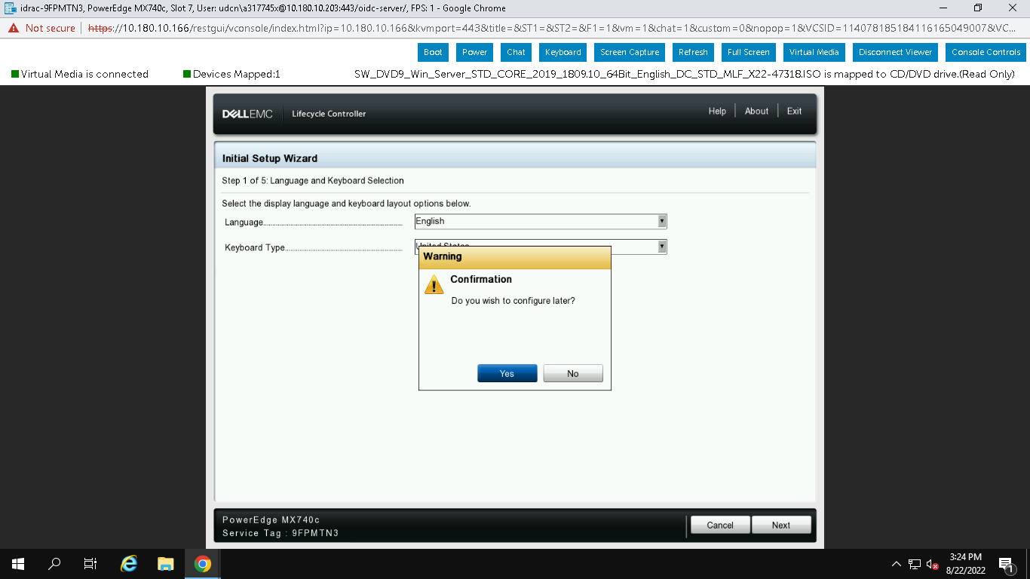

1. Select OS Deployment and click Deploy OS

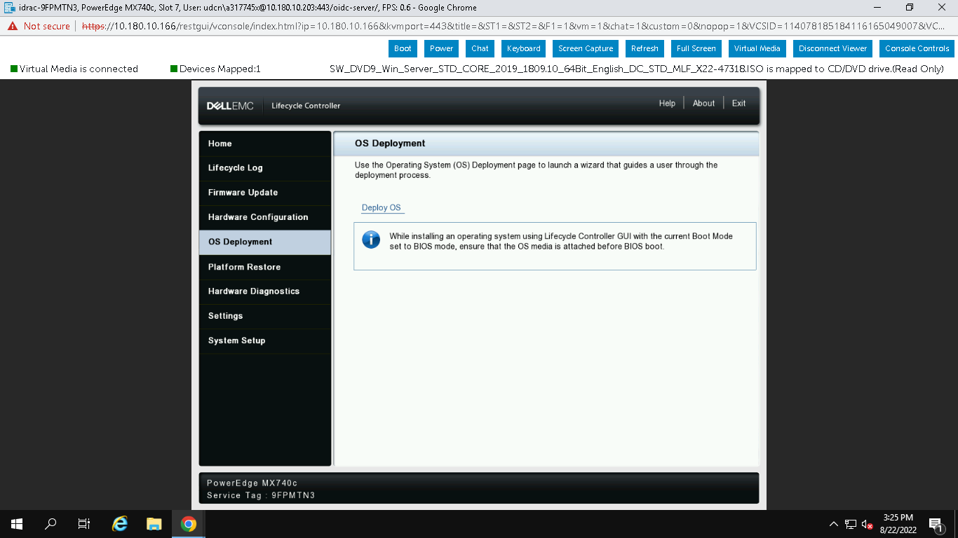

K) Review the settinngs and click next

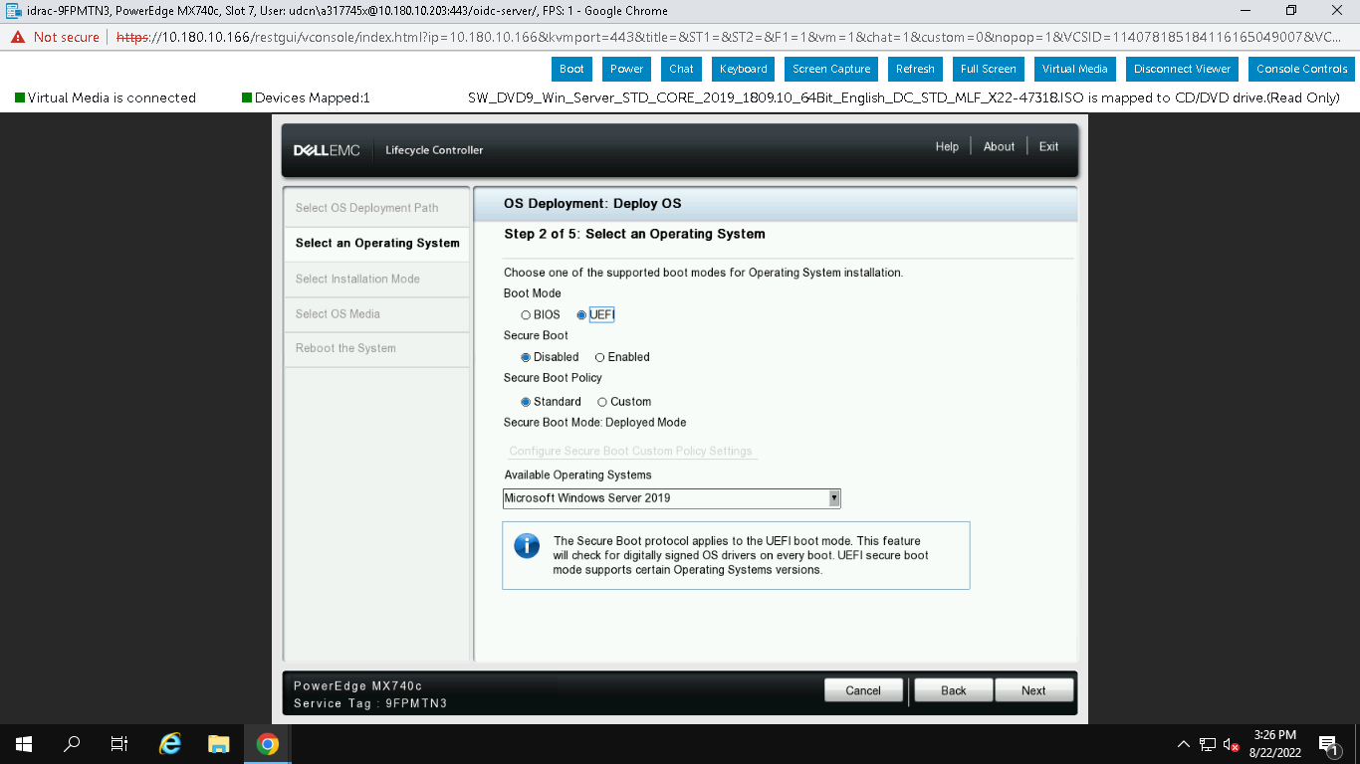

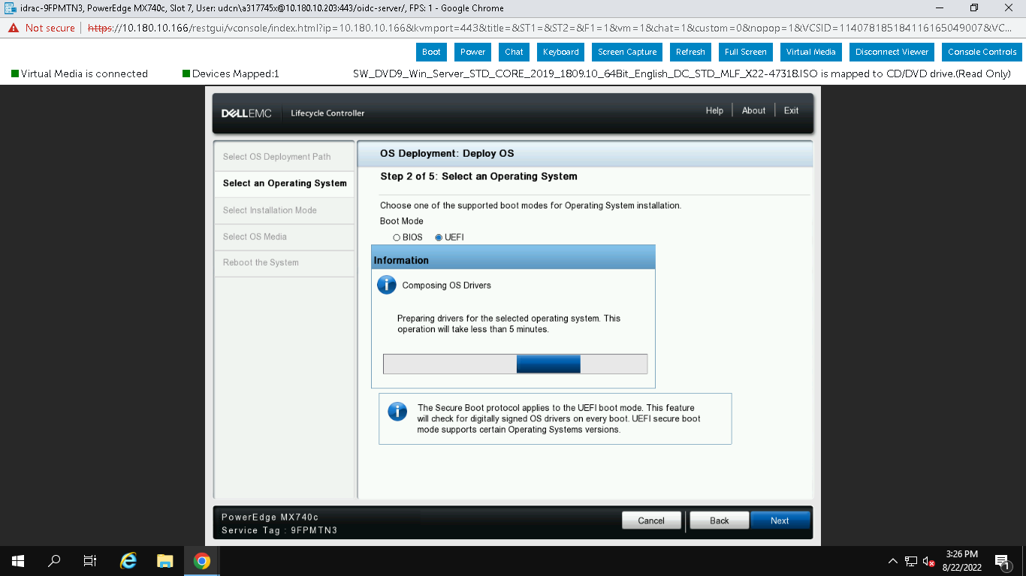

l) select manual install and click next

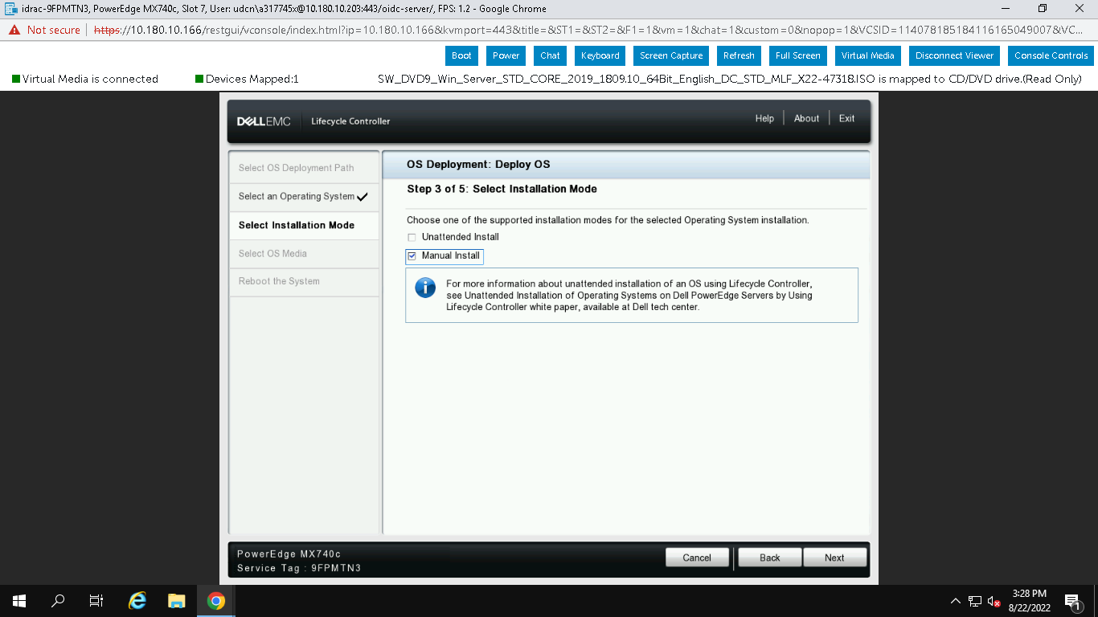

m) Select the Windows 2019 from drop down and click next

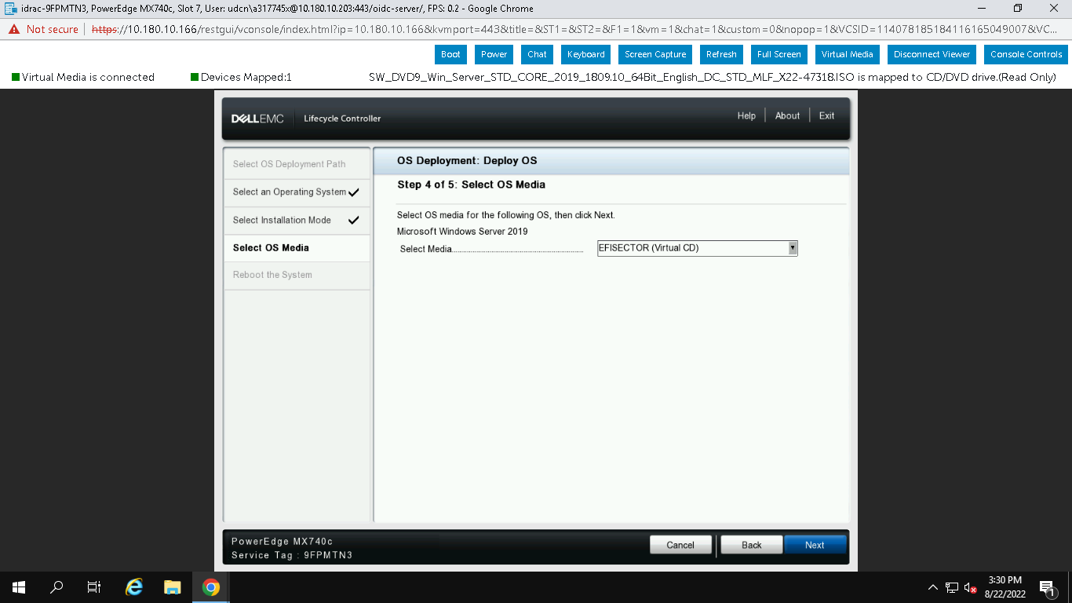

n) Select Desktop experience and click next and accept the License

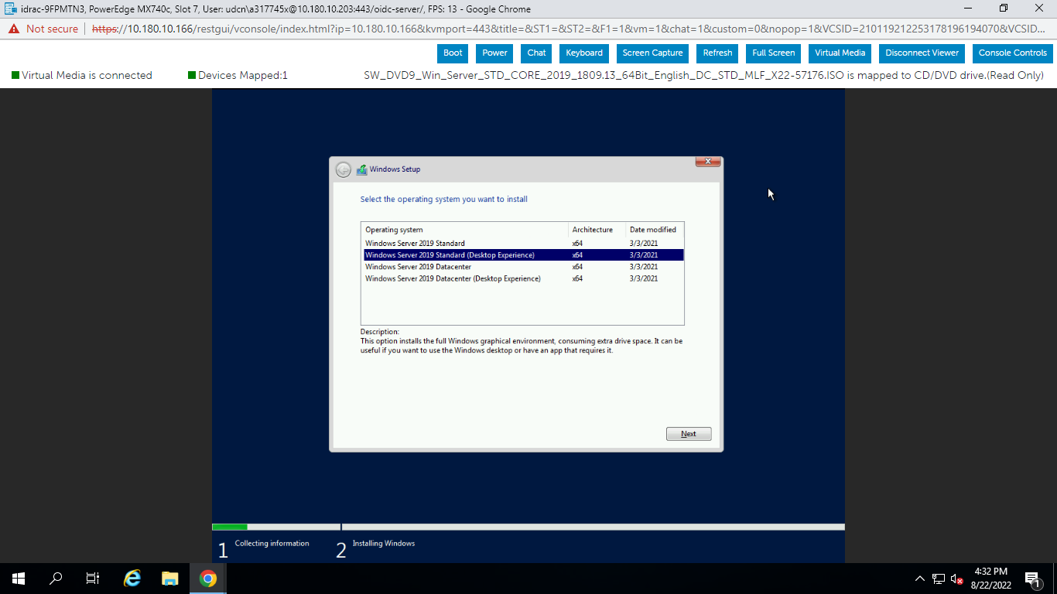

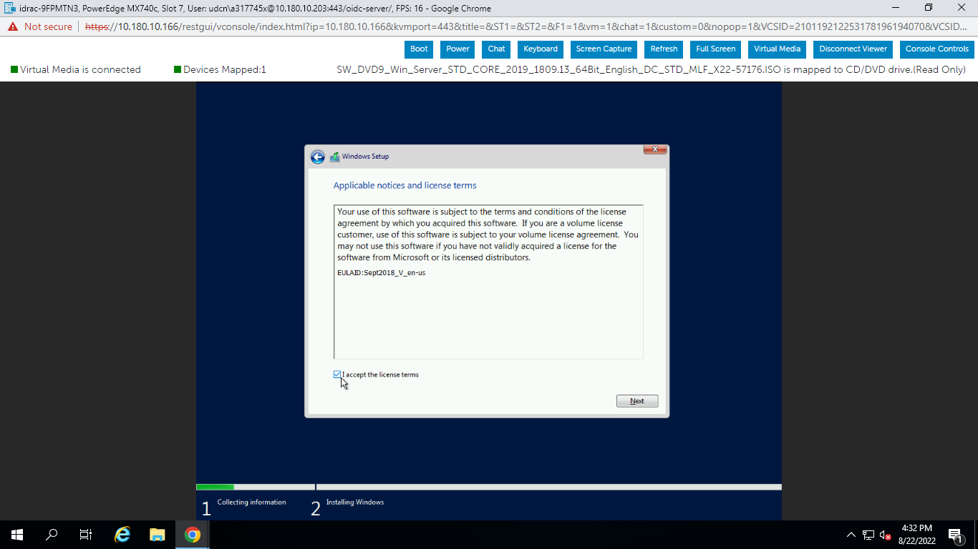

o) Disks will be visible below like this once boot lun is allocated from the storage end . Click next to proceed further

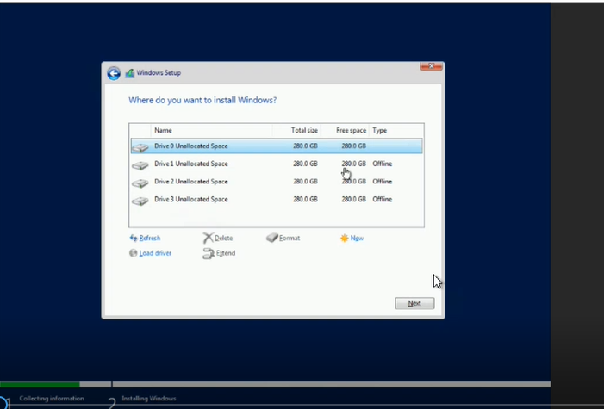

p) Once copying done OS installation will complete and server will reboot

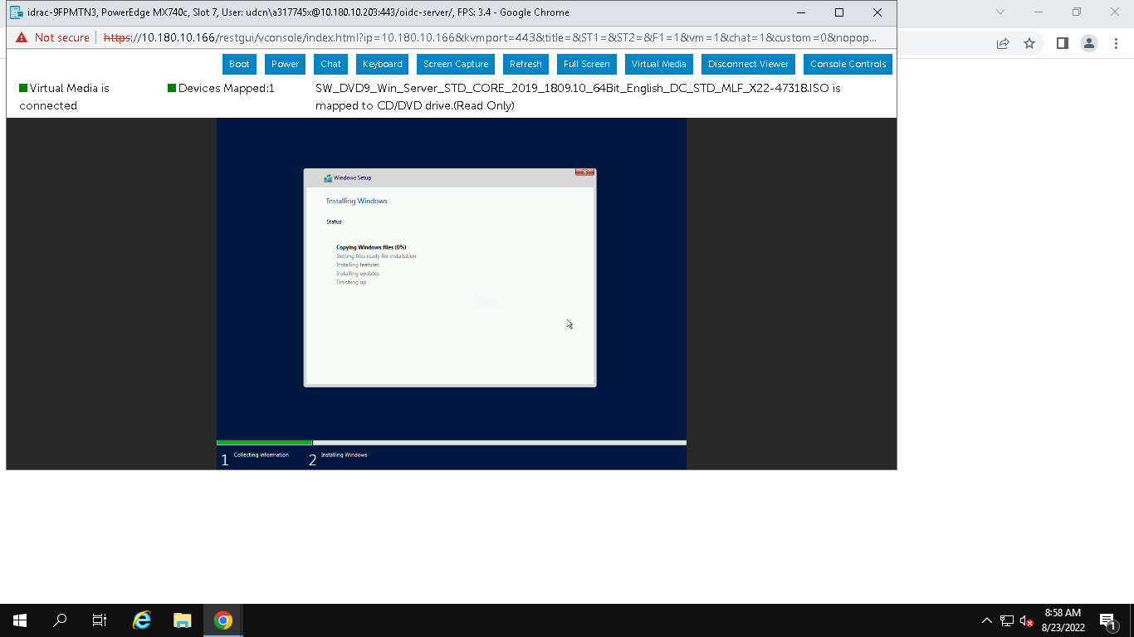

q) Set the Admin password to login to server

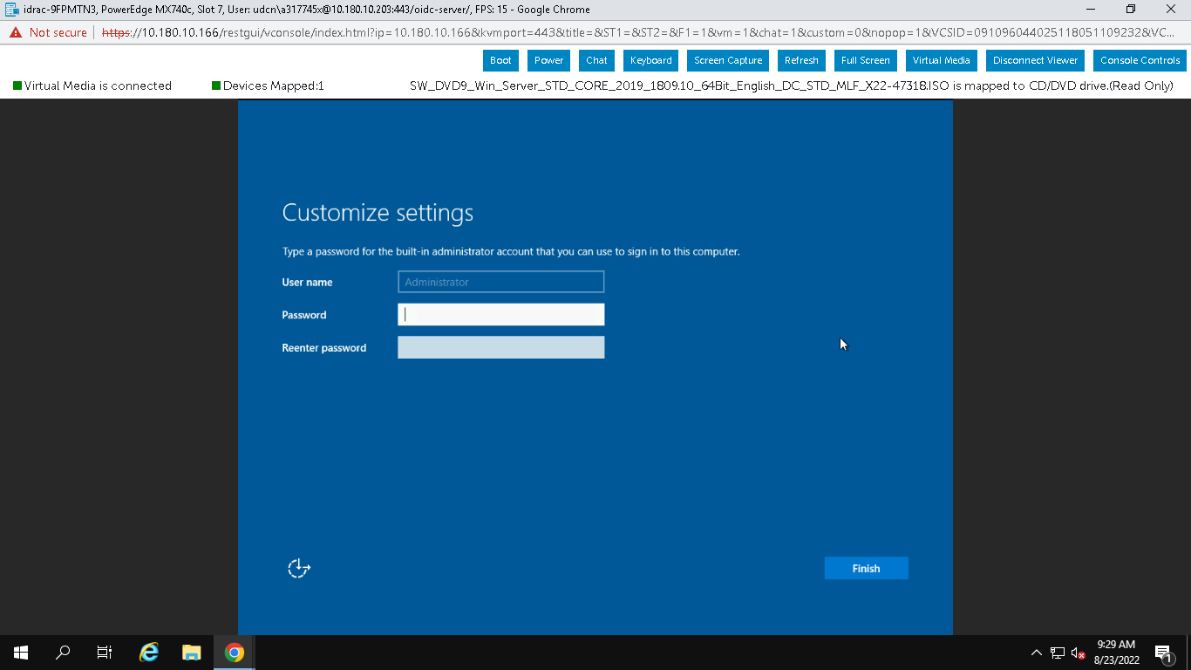

# How to update Drivers and Firmware

1. Once OS successfully installed and logged in with administrator account, mount the SUU ISO

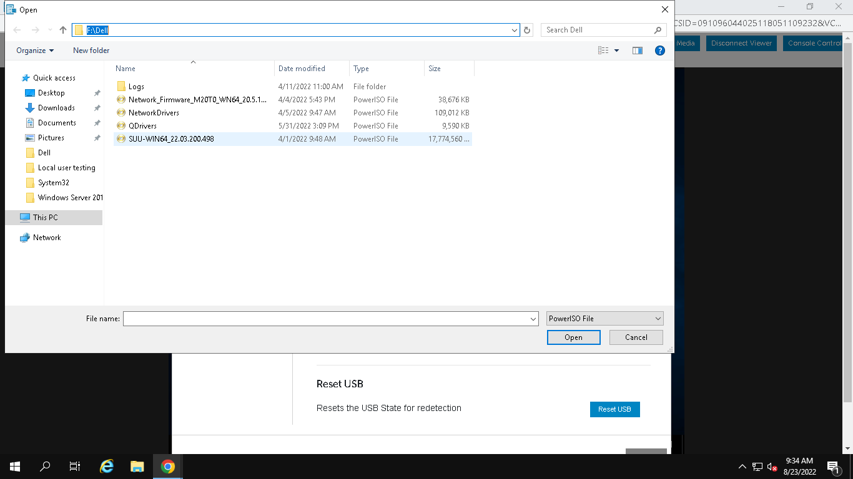

1. Open the drive where ISO is located and run SUU launcher with Admin Privileges

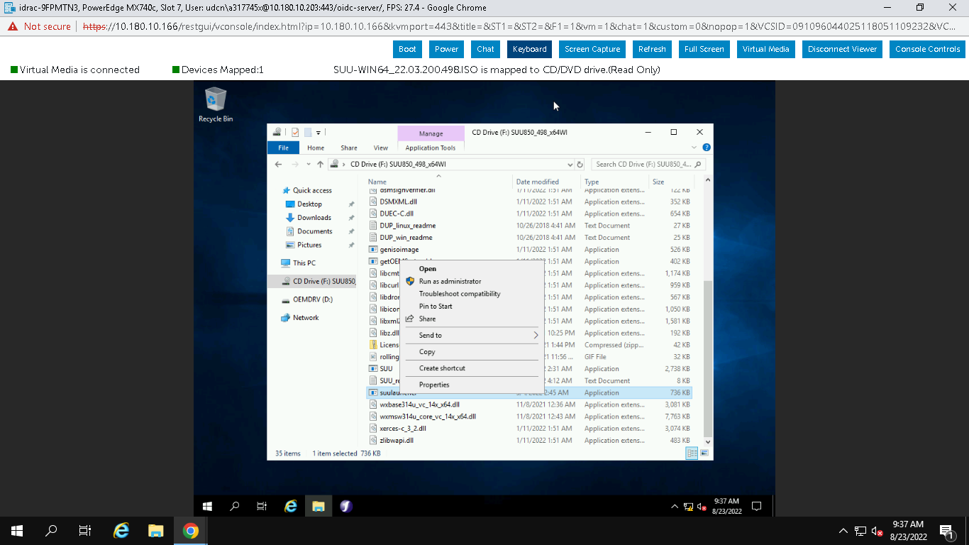

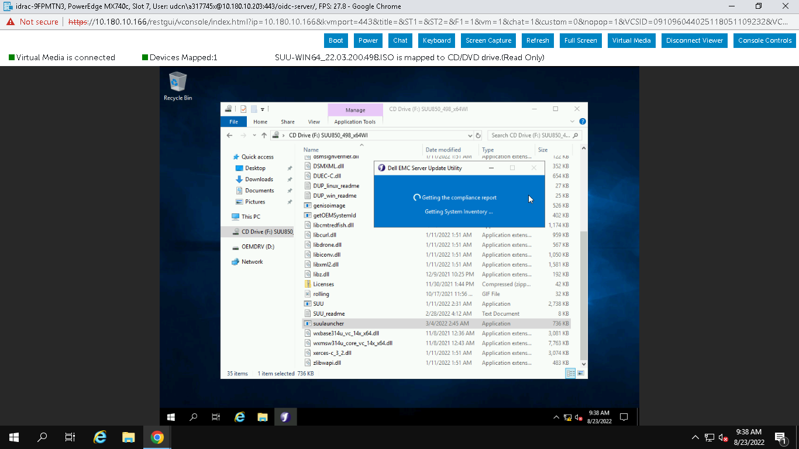

1. Once the launcher is successfully completed, it will display the list of drivers and Firware which needs to be installed or upgraded

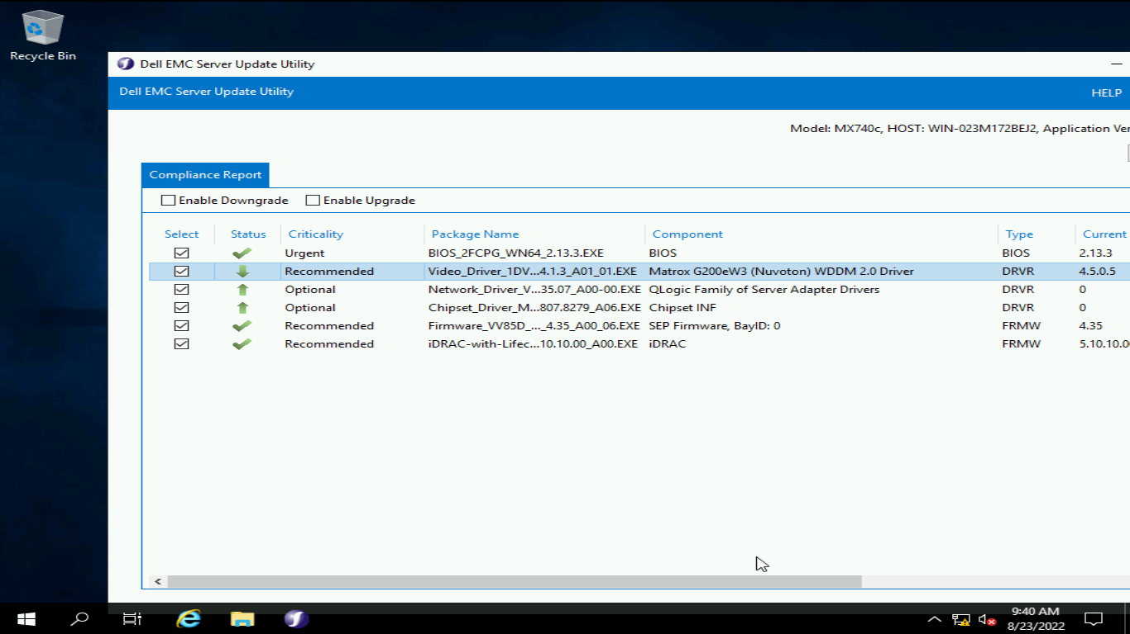

1. Select the required drivers and firmware and click apply.

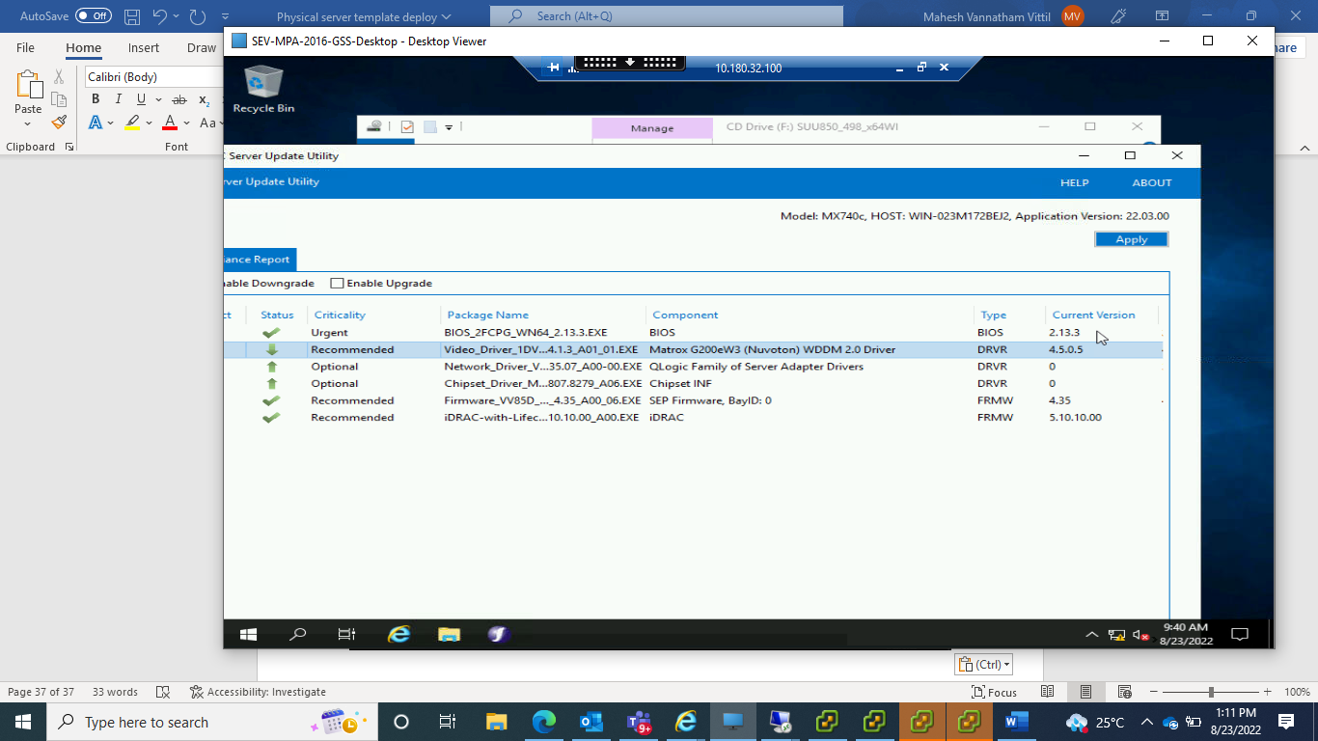

1. Once the drivers are updated, it wil prompt for reboot. Reboot the server to complete the driver and firmware upgrade.

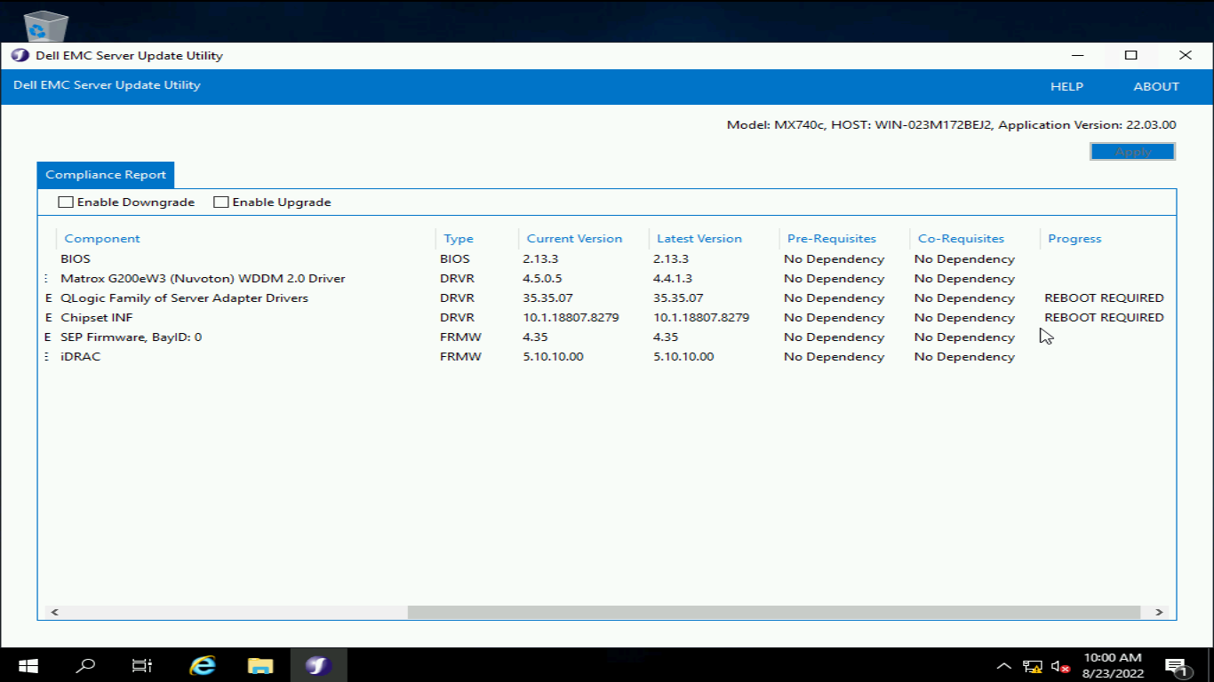

# 7.How to Configure NIC Teaming

1. Select Local server from Server manager and then select NIC teaming as shown in the below screen

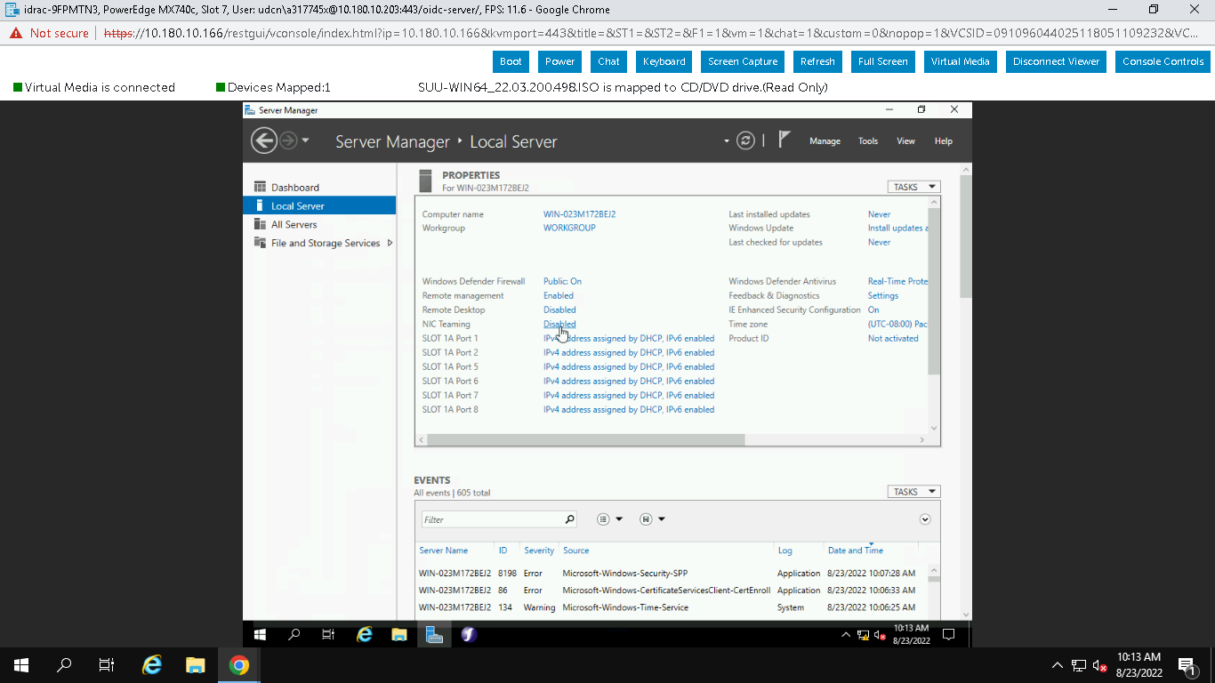

1. In Adapters and Interfaces, select the NICS which needs to be part of NIC teaming and in the tasks select Add to New Team

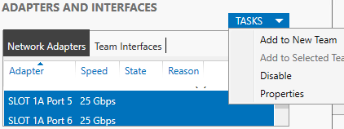

1. Provide the Team name and select any one NIC as standby and then select Default Vlan to assign the Vlan number. In the specify Vlan mention the Vlan number and click ok. For Public always use Port1 and port2. For backup it should be Port7 and Port8

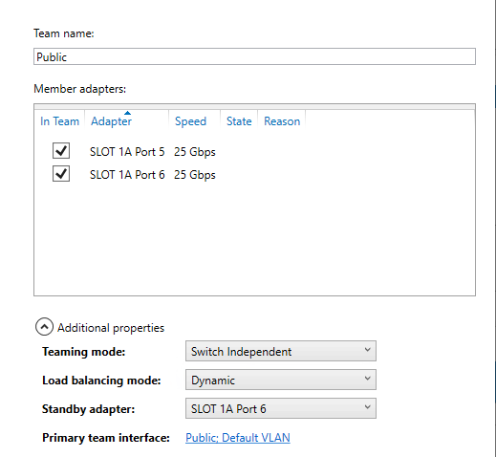

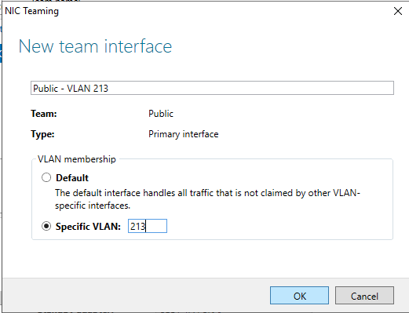

1. Repeat step c for configuring Backup teaming. Once the teaming is done under Team interfaces it will show as mentioned below

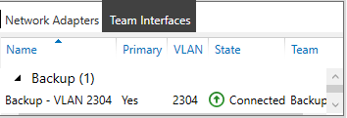

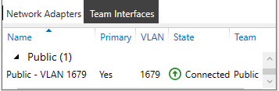

1. From network connecions end will show the NIC cards as shown below

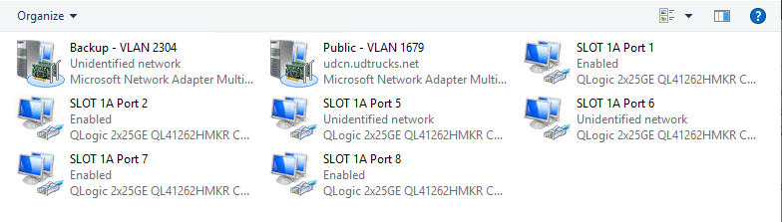

1. Rename the NIC’s as per SOE standard and disable unused networks.

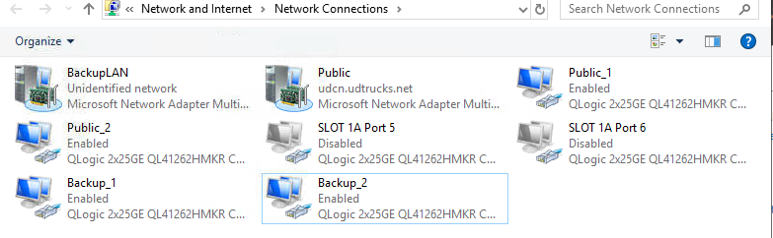

1. Client for Microsoft Networks and File and Printer sharing for Microsoft networks should be disabled for BackupLan

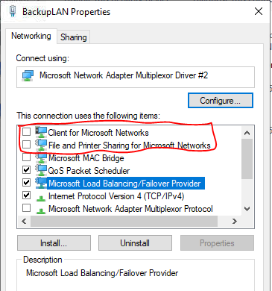

1. Assign the IP

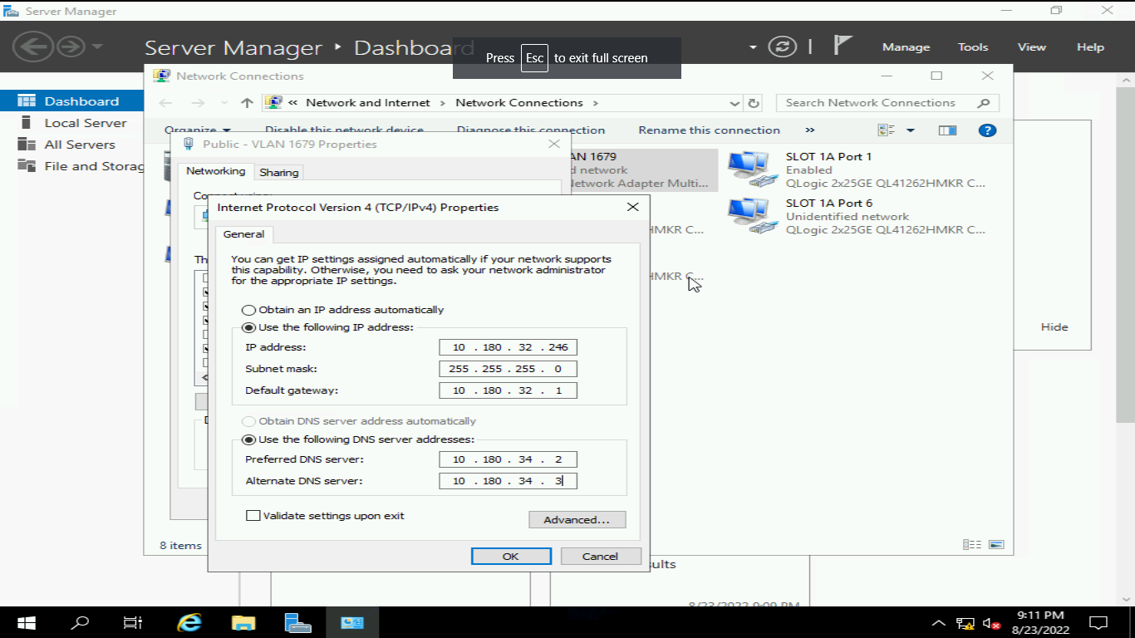

1. Join the server to domain and reboot it

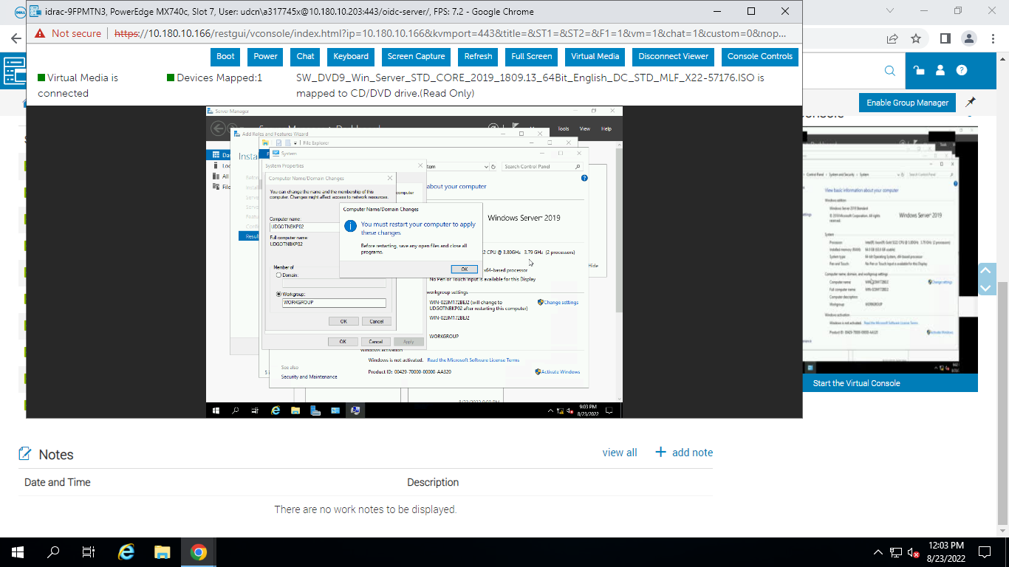

# 8.Place server in Right OU and check the Respective GPO’s

a) Server should be placed in the highlighted OU based on the requiremnet

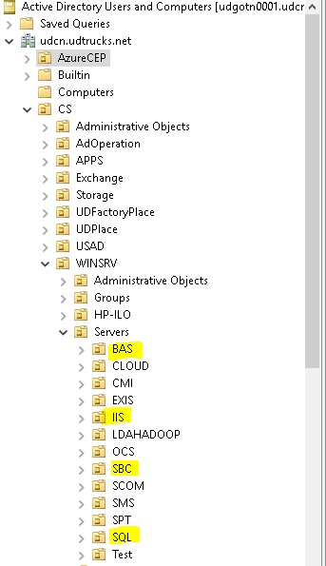

b) Server should be member of the below Gpo’s based on the product type, environment, Maintenance window and service plan

For SQL and IIS server, need to add respective GPO’s based on the OS.

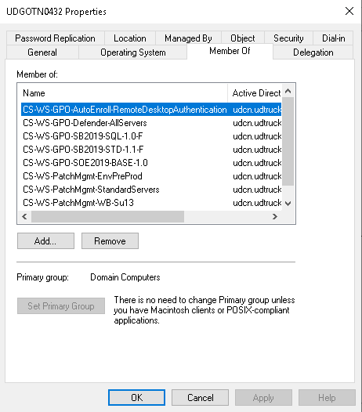

CS-WS-GPO-AutoEnroll-RemoteDesktopAuthentication- This GPO for Certificate and RDP authentication

CS-WS-GPO-Defender-AllServers – This GPO for applying settings related to Windows defender

CS-WS-GPO-SB2019-STD-1.1-F – Standard GPO based on the OS

CS-WS-PatchMgmt-EnvProd – GPO based on the type of Environment

CS-WS-PatchMgmt-BasicServers - GPO based on the Service plan

CS-WS-PatchMgmt-WA-Fr13 – GPO based on the Maintenance Windows

CS-WS-GPO-SOE2019-BASE-1.0 – Base GPO based on the OS.

CS-WS-GPO-SB2019-SQL-1.1-F – GPO for SQL based on the OS

CS-WS-GPO-SB2019-IIS-1.1-F – GPO for IIS based on the OS

# Tools Installation and configuration

# i) Big Fix Agent installation and configuration

a) Tools dump located in the path \\udgotn0190\e$

b) Copy the required agent and save it in the Temp folder. Big fix agent contains three folders first one is exe , second and third for the configuration and supporting files based on the site

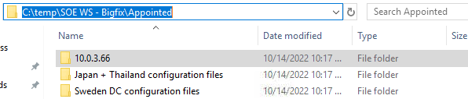

c) For Sweden we have 2 pairs, if the server is placing in DC, need to use HA1 Pair and if server placing in ARDH, need to use HA2 Pair.

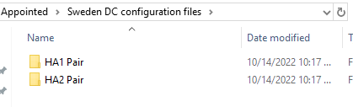

d) If server is placing in DC, copy the files Clinetssettings.cfg and masthead.afxm to the folder 10.0.3.66. Once copying done, run the BigFix-BES-Client-10.0.3.66

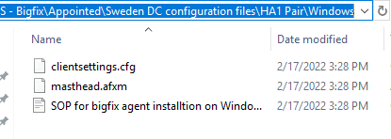

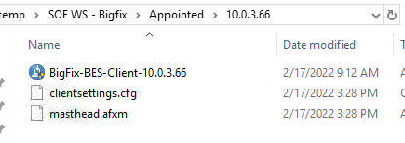

1. Select language as English and click OK

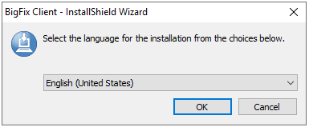

1. Read the description and click next

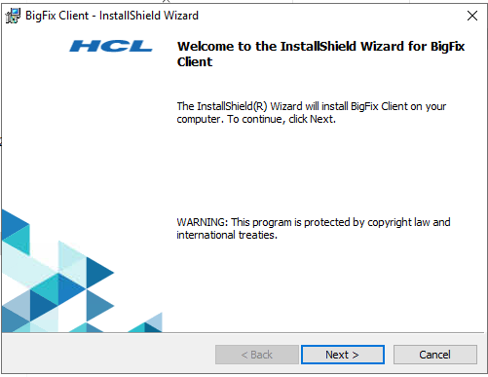

1. Let the installation path be default and click next

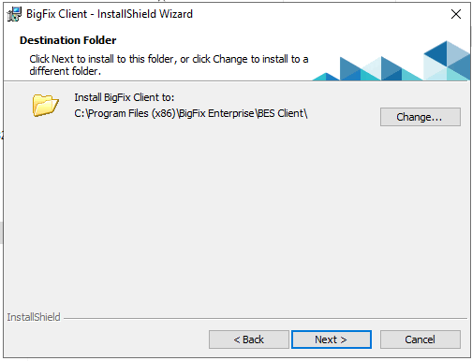

1. Click install to proceed further

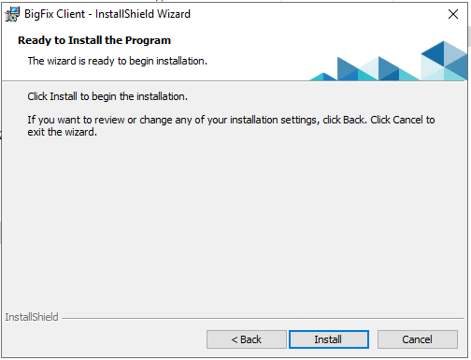

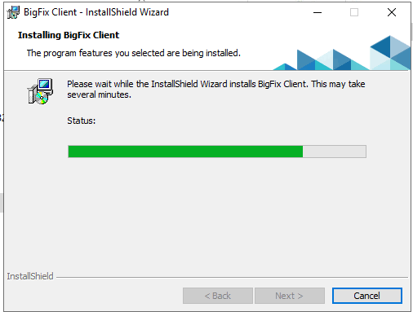

1. Click finish to exit the console

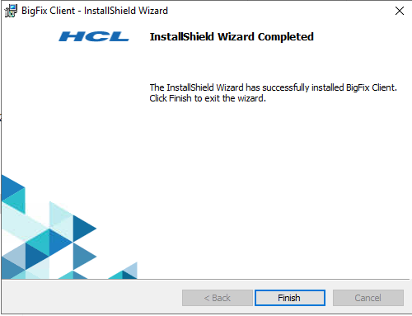

K )Once the agent is installed login to the server 10.180.33.36 to verify whether server is Reporitng to Big fix console .Click Big fix console and it will prompt for credentials. Provide the credentials and click Login

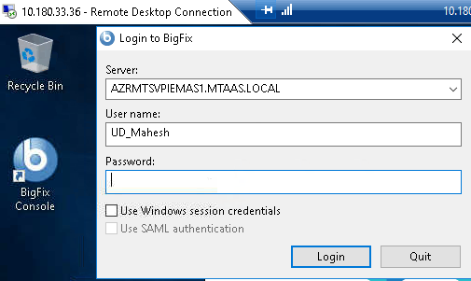

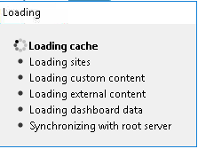

l ) once the page is loaded select All Patch Management

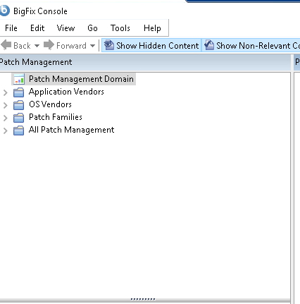

m ) In all patch Management select Computers

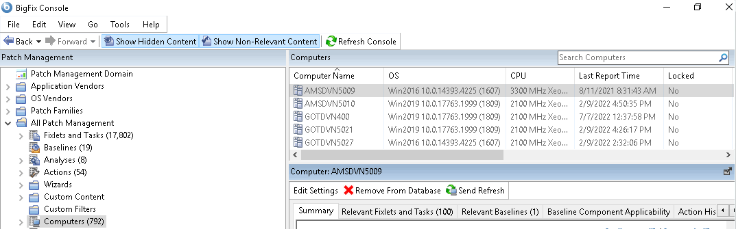

n ) In the search column, type the Computer name where the Big Fix agent is installed and it will reflect the Computer name in the Computers

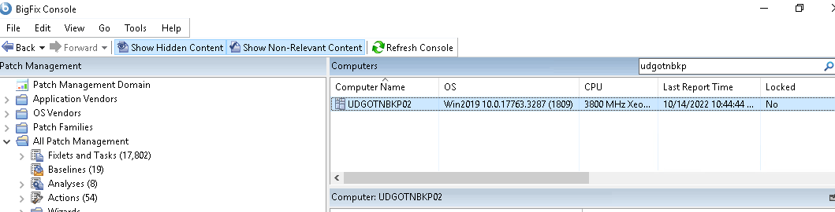

# ii) Nimsoft Agent installation and configuration

1. Nimsoft agent contains two files one is setup file and another one is Configuration file

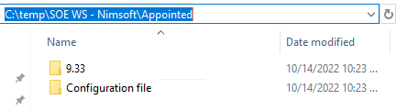

1. For Gothenburga and Japan have different configuration files

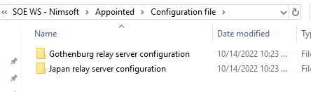

1. For Gothenburg, have two config files based on the DC.

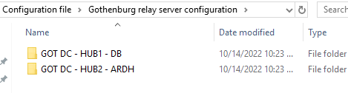

1. If server is placing in DB DC copy the robot -vars.cfg file from configuration folder and copy it to the setup file and same goes for Japan and ARDH

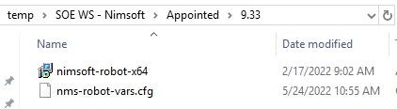

1. Once the file is copied,run the exe. And click next

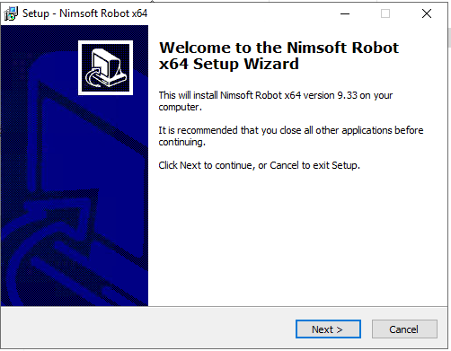

1. Select the default path for installation and click next

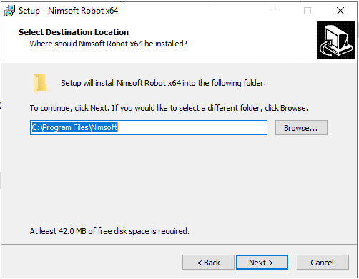

1. Click yes to proceed further

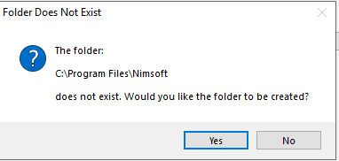

1. Click install

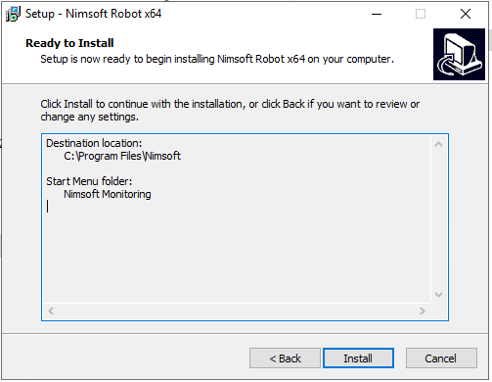

1. During installation it will prompt for many windows and click ok

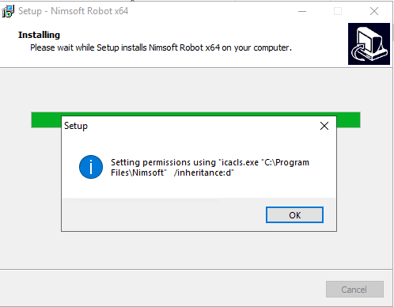

1. Click finish to exit the console

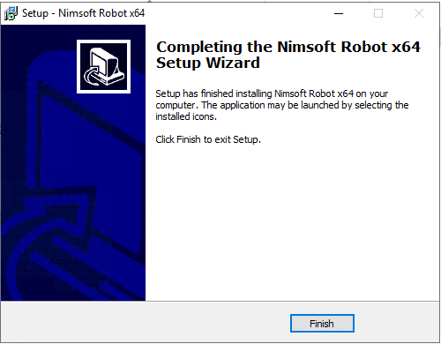

1. Once installation done, make sure Nimsoft Robot Watcher service should be in Automatic and running condition



1. Open the Nimsoft Service Controller and it will show where the server is reporting

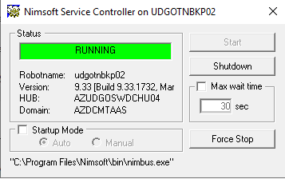

1. Login to server 10.180.32.103 and from the start menu Open Infrastructure Manager from Nimsoft Monitoring

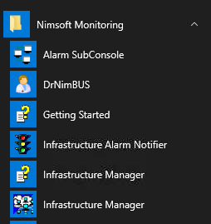

1. Provide the credentials, to login to Nimsoft console

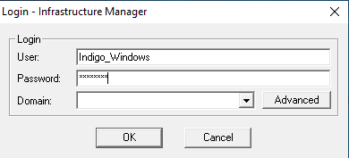

1. Once successfully logged in ,Nimsoft monitoring console looks like below.

First Two servers for Japan site

AZUDGOSWDCHU01 is the Primary server for DB DC and AZUDGOSWDCHU03 is the secondary server for DB DC

AZUDGOSWDCHU04 is the Primary server for ARDDH DC and AZUDGOSWDCHU02 is the Secondary server for ARDH DC

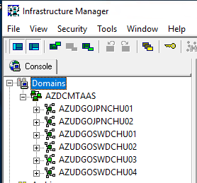

1. Since the server is placed in ARDH Dc and it should report to ARDH primary server as shown below.

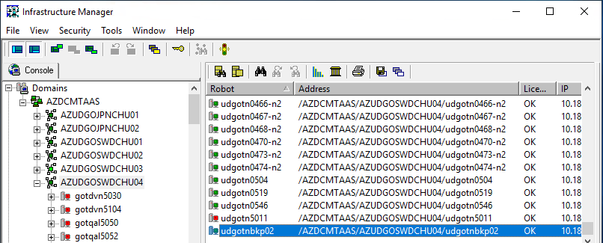

1. Robot.cfg file looks like below and if server needs to report to DB DC, Stop the Nimsoft service and make the necessary changes in the file based on DC

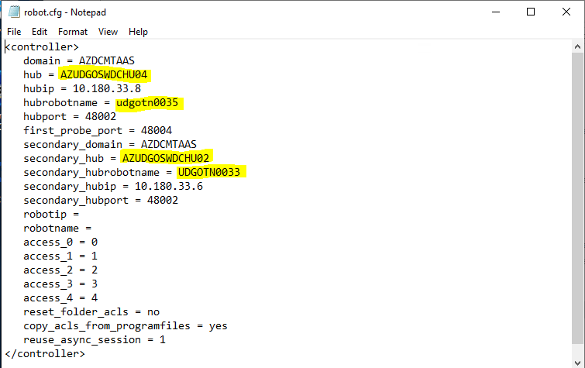

# iii) Qualys Agent installation

1. Run CMD with Admin privileges
2. Go the path mentioned below and run the command .

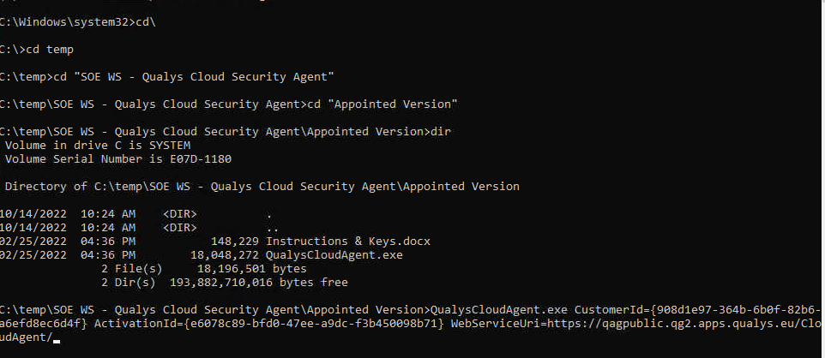

QualysCloudAgent.exe CustomerId={908d1e97-364b-6b0f-82b6-a6efd8ec6d4f} ActivationId={e6078c89-bfd0-47ee-a9dc-f3b450098b71} WebServiceUri=https://qagpublic.qg2.apps.qualys.eu/CloudAgent/

1. Once the agent is installed, sent mail to Udsecurity team whether server is reporting to Qulays Console or not

# iv) Qradar Agent installtion

1. Go to Run and open CMD with Admin privileges
2. Go the path mentioned below and run commands based on Site

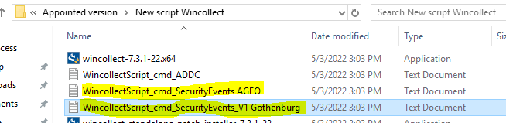

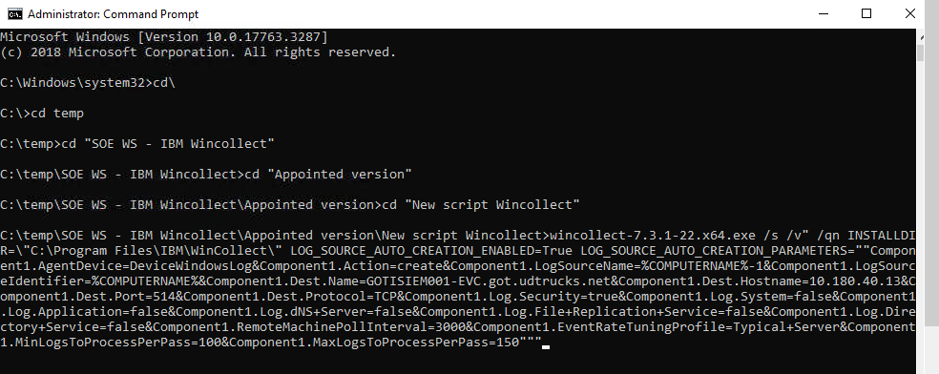

C) Send mail to UDsecurity team to check whether server reporting to Qradar console

UDTrucksNetworkSecurity [UDTNetworkSecurity@hcl.com](mailto:UDTNetworkSecurity@hcl.com)

# v) TSM Agent installation

a) Run the IBM Spectrum Protect Client and click next

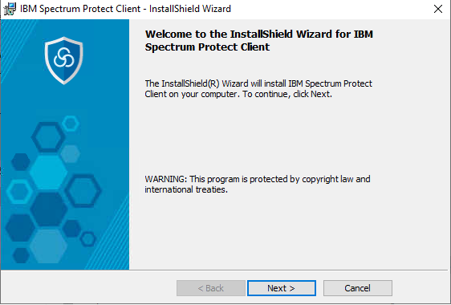

b ) Let the path be default and click next

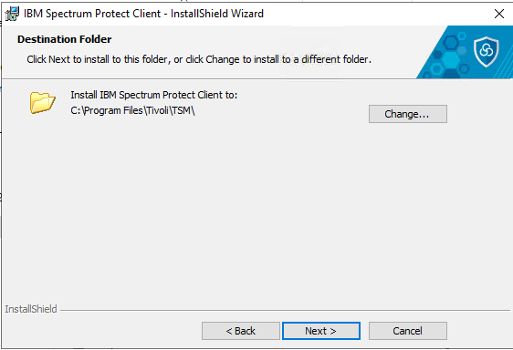

C ) Select typical and click next

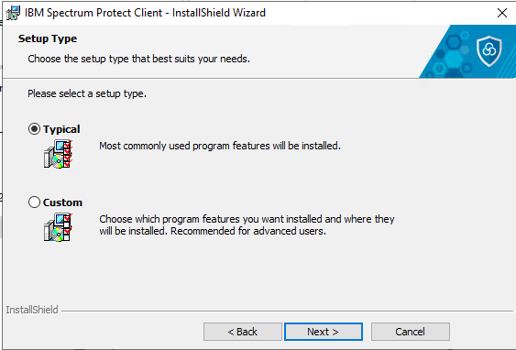

d ) Click install

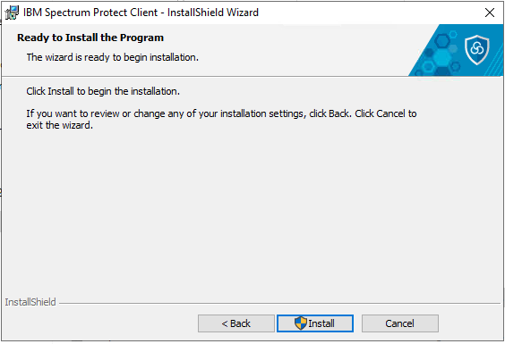

e ) Click finish to exit the console

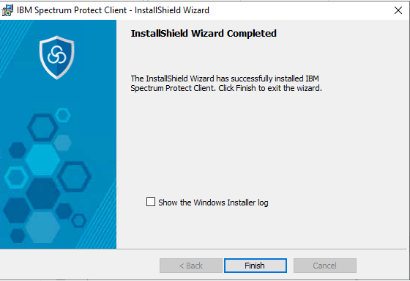

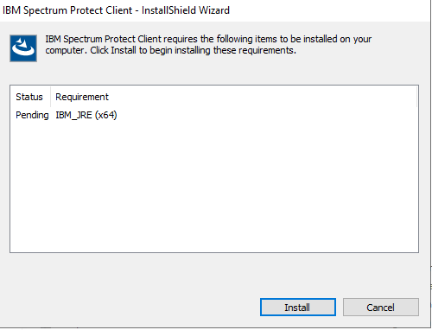

# . Backup configuration For Nodes

a ) Once agent is installed, browse to the below path and open DSM

C:\Program Files\tivoli\TSM\baclient

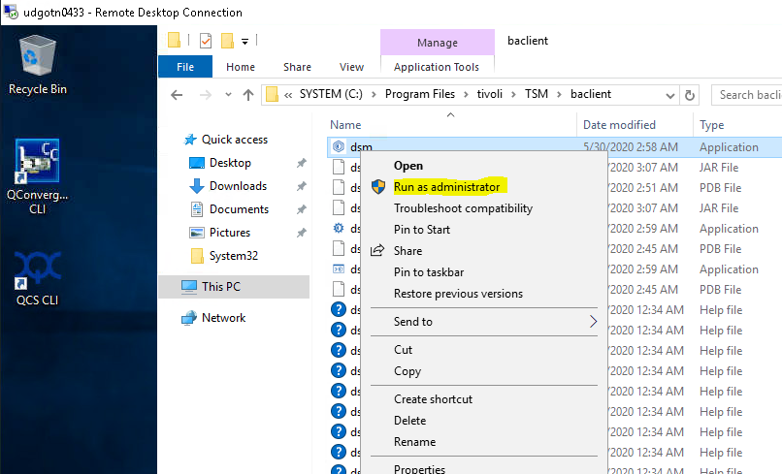

b ) Click next to create options file

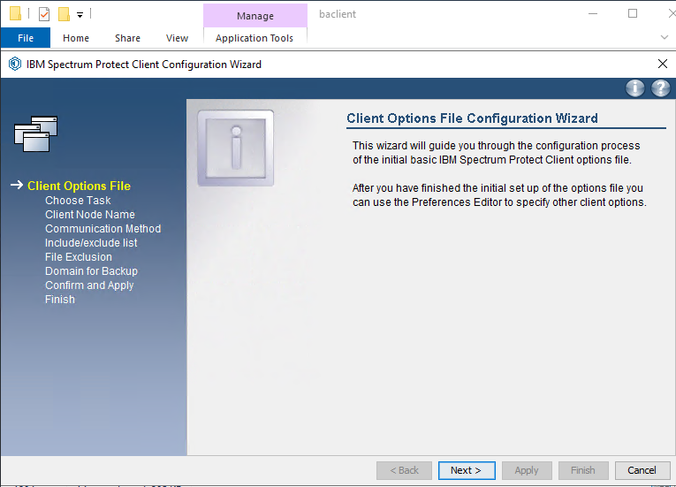

C ) Provide the server name and click next

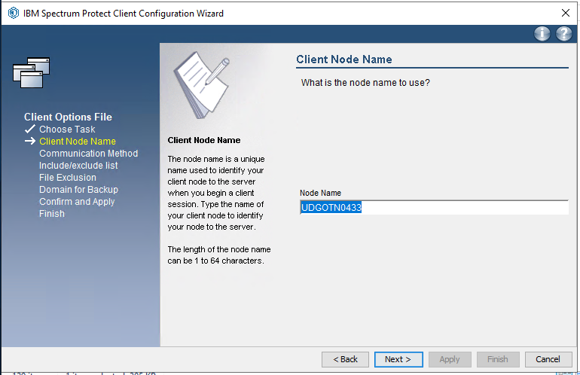

d ) Select TCP/IP and click next

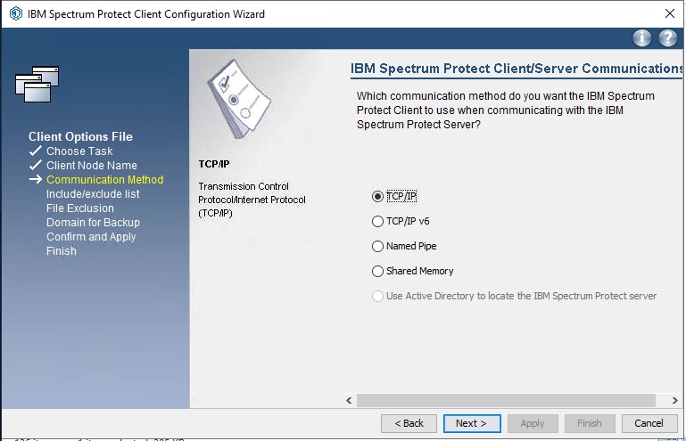

e ) Click select all and proceed further

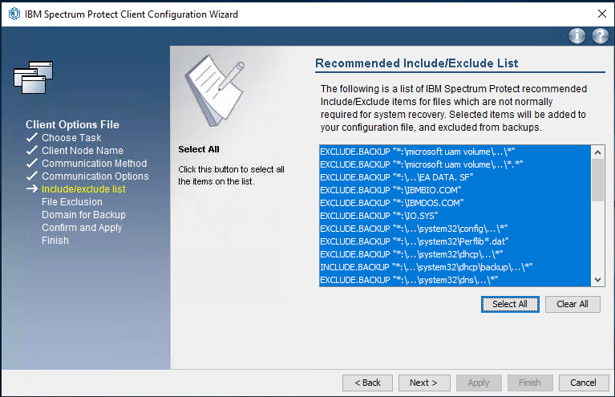

f ) click next

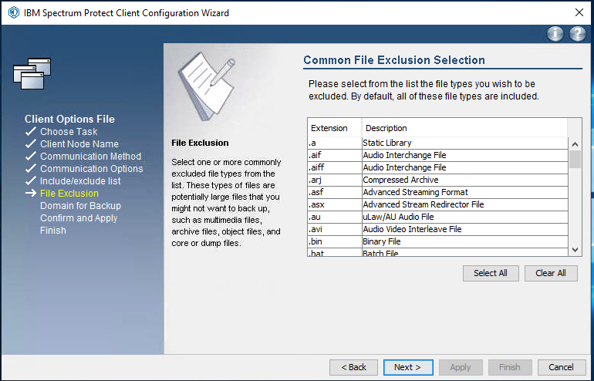

g ) Select the drives which needs to be part of backup and click next

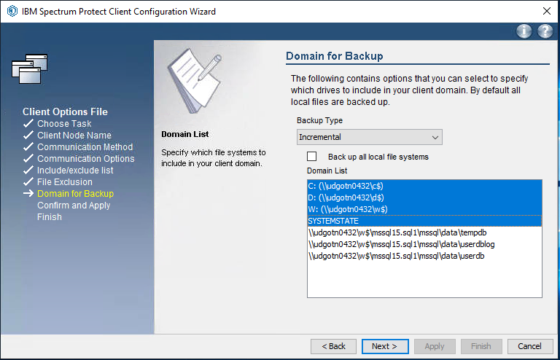

h )click apply

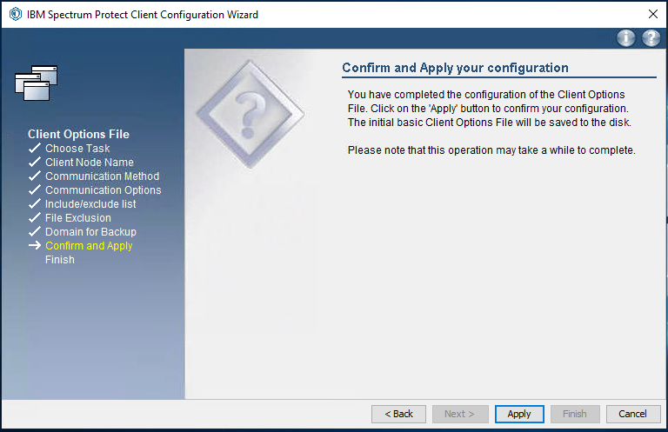

i ) click finish to exit the console

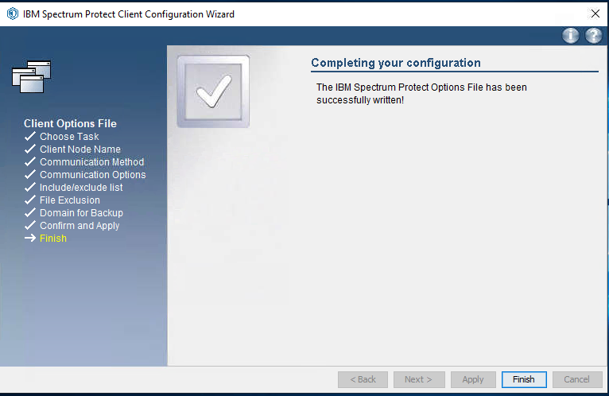

j ) open the dsm.opt file and append the below entries

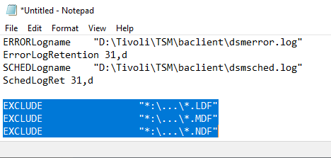

k )Open the mentioned path below and type dsmc, so that it will prompt for password. Password will be provided by Backup team

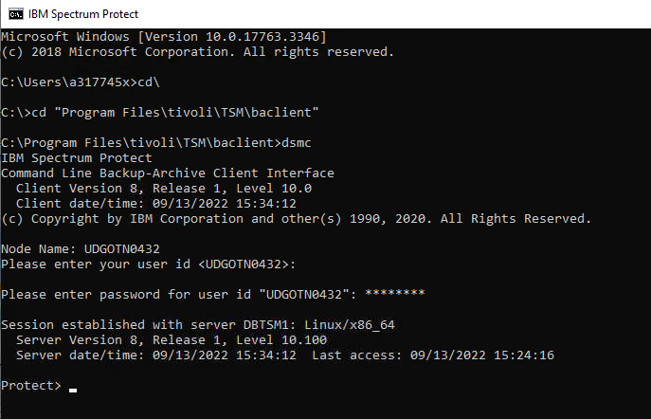

l ) Open IBM spectrum Protect and select setup from utilities

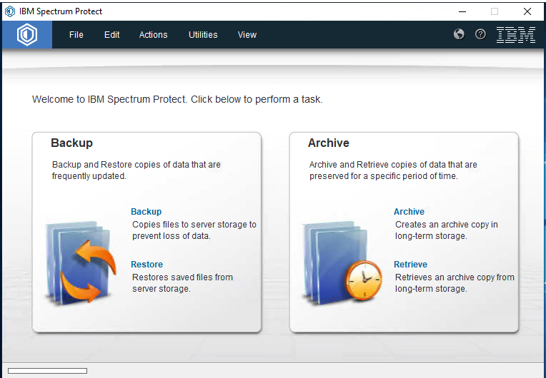

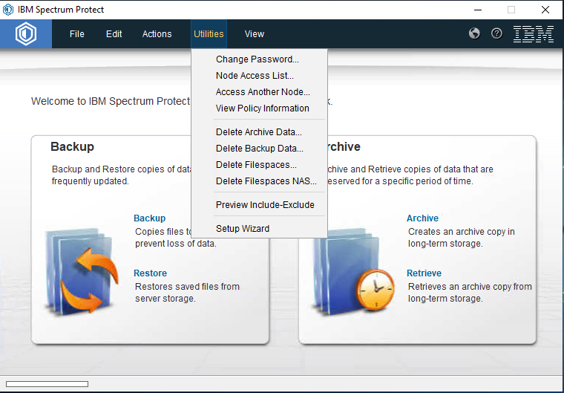

m ) Select Help me configure the client scheduler and click next

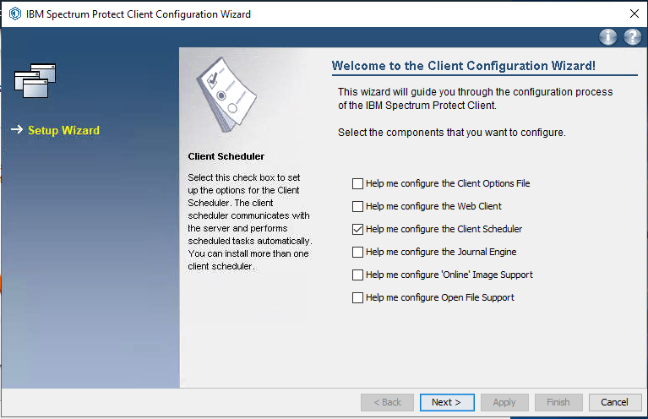

n ) Click next

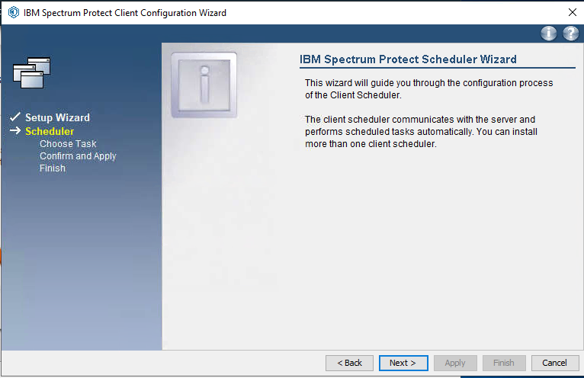

o ) Select the option as shown in the screenshot

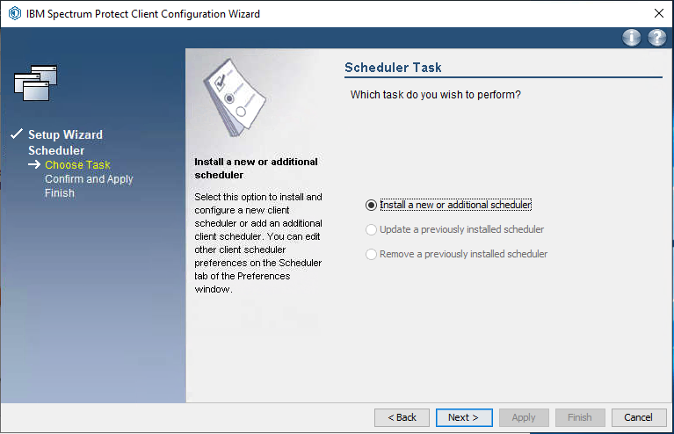

p ) Provide name as TSM Client Scheduler

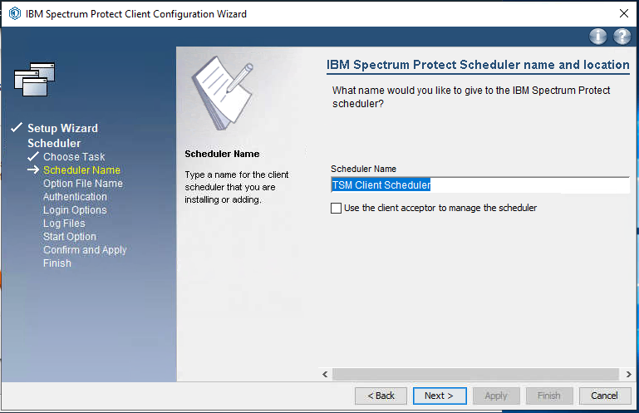

q ) Select the option as shown below and click next

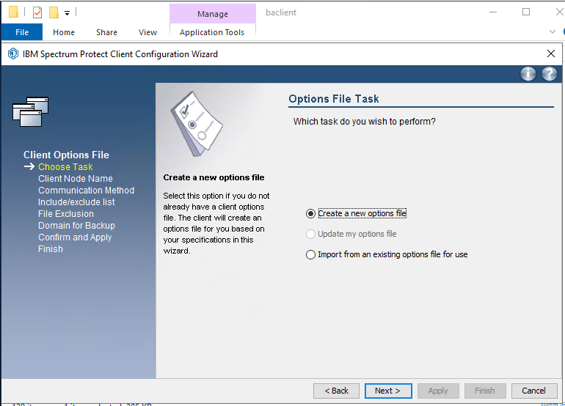

r ) Provide the password shared by Backup team and click next

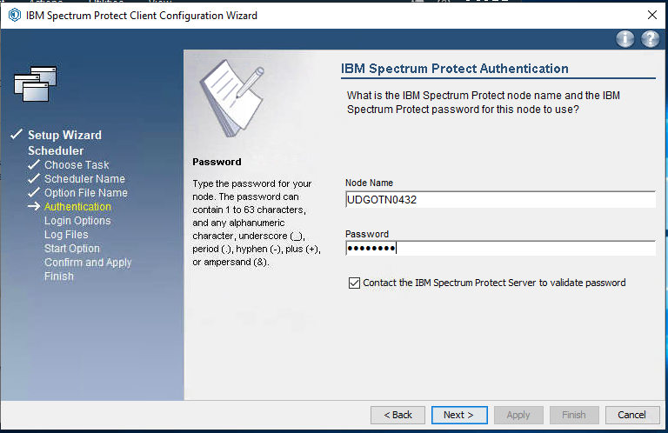

s ) Select the default option and click next

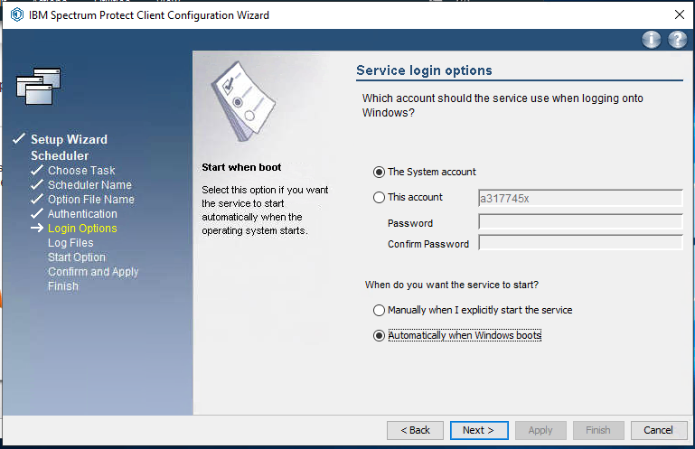

t ) Provide the path for Error and schedule log and click next

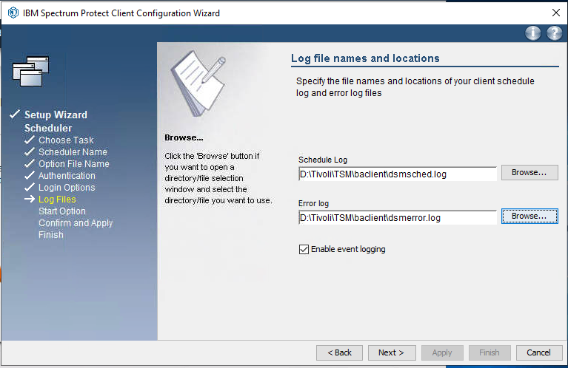

u ) Select yes and click next

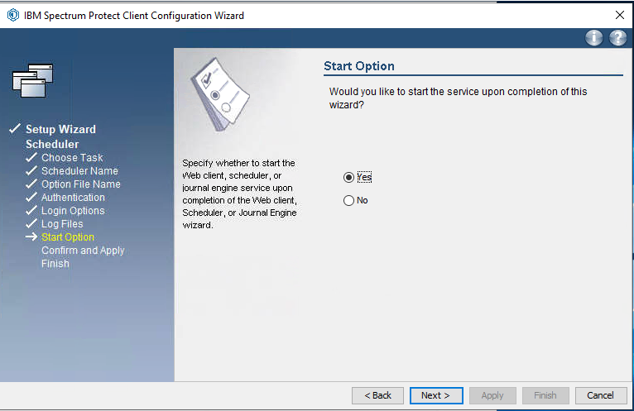

v ) Click apply

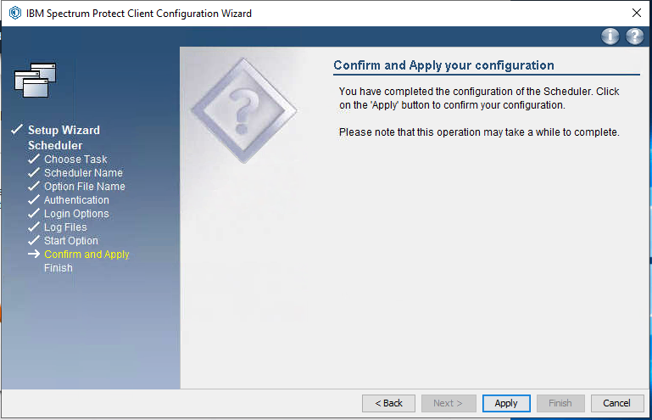

# .Cluster Resource Backup Configuration

1. From the setup Select Help me protect my cluster

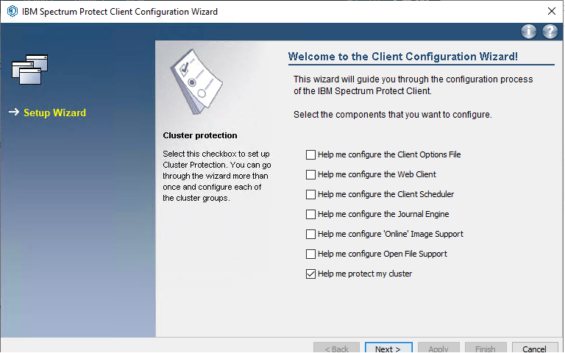

1. Click next to proceed further.

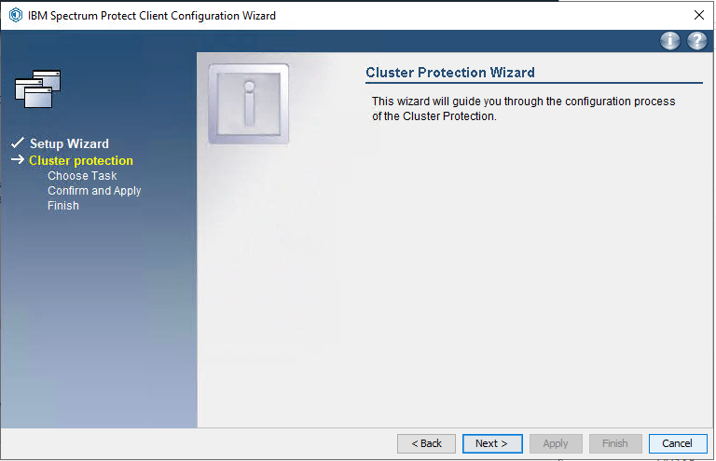

1. Select the option and click next

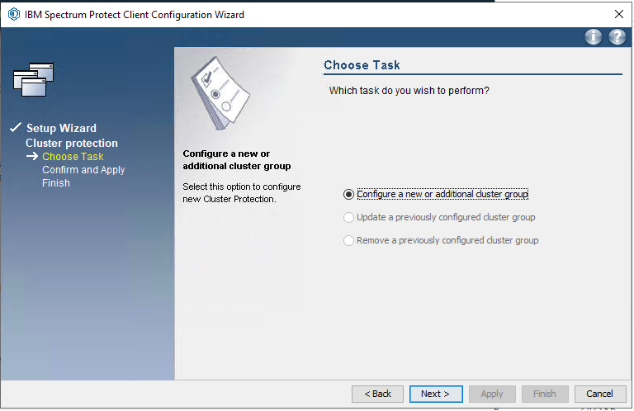

1. Select the cluster resource group and click next.

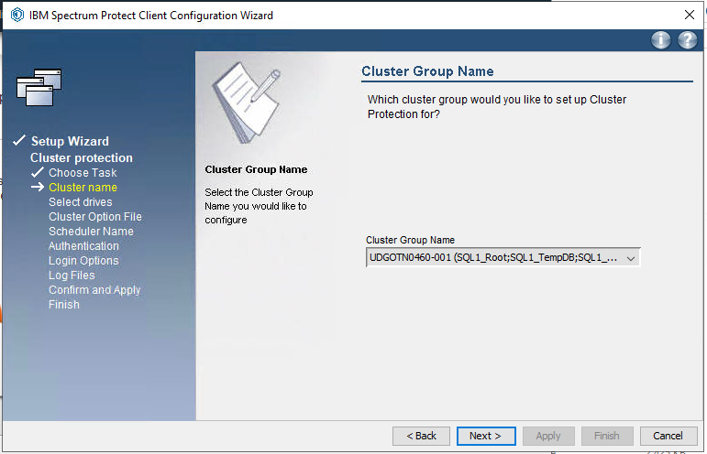

1. Select the drives and click next

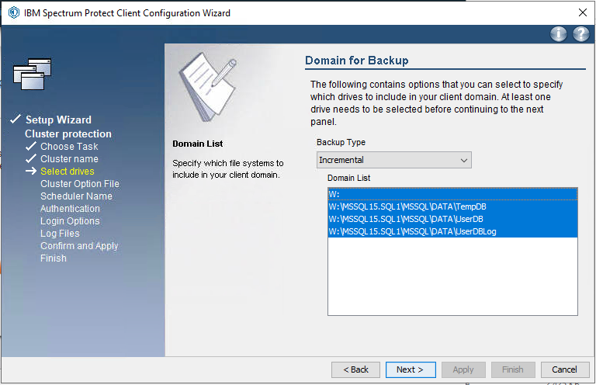

1. Provide the path for Opt file and click next

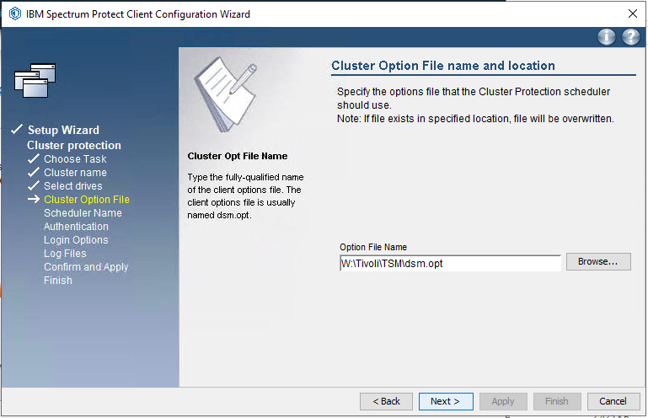

1. Provide the service name and click next

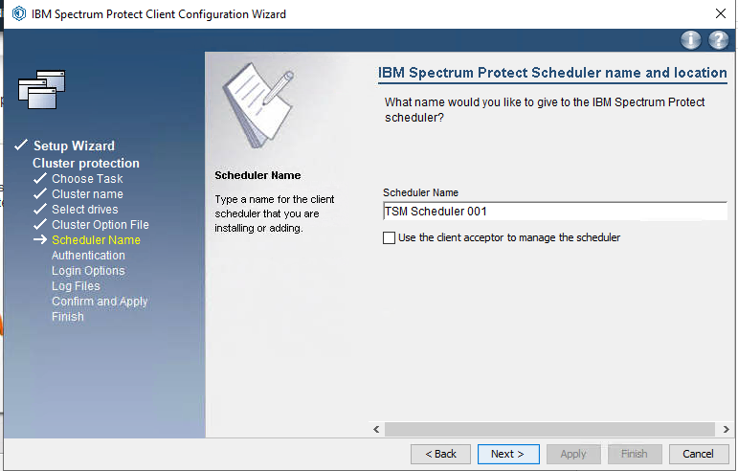

1. Provide the password and click next

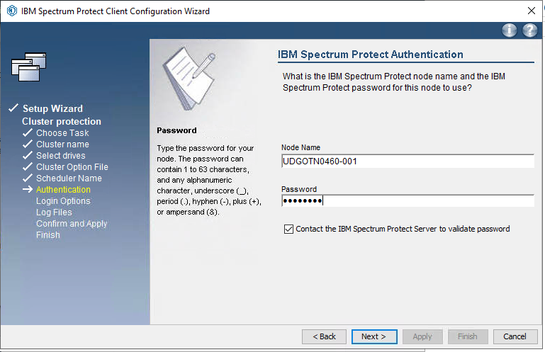

i) Select the default values and click next

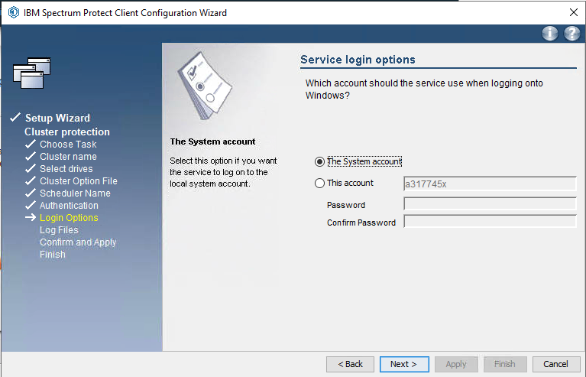

J Provide path for Error and schedule logs then click next

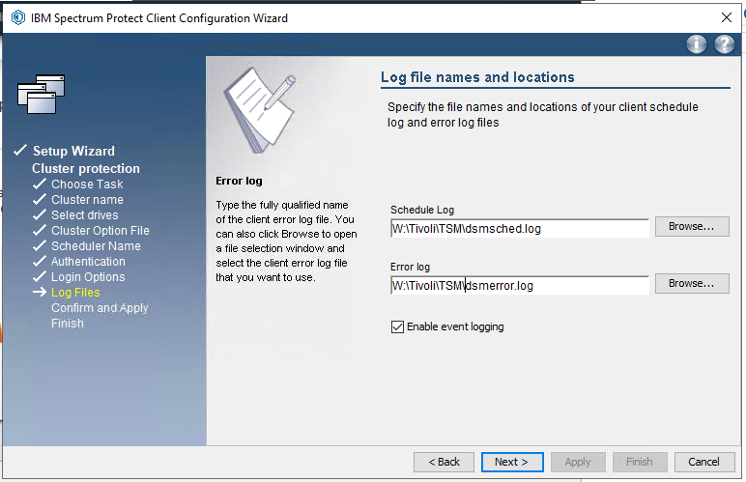

1. Click apply

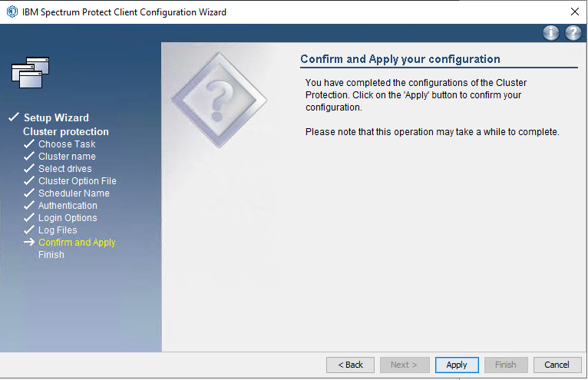

1. Click finish to complete the wizard

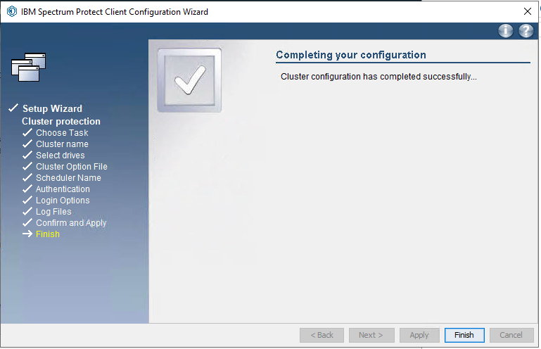

.

END OF DOCUMENT